Optimisation of Space, Time and Economy in Transportation
1. P. R. Chorage, MANET, PUNE , pratik.chorage001@gmail.com
2. P. A. Potghan, MANET, PUNE , ppotghan@gmail.com
3.P. V. Welye, MANET, PUNE , welyepratik96@gmail.com

ABSTRACT
Around 90% of the world trade is carried by the international shipping industry. Without shipping import and export of goods on the scale necessary for the modern world not be possible. Seaborne trade continues to expand, bringing benefits for consumers across the world though competitive freight cost. As the shipping is new developed mode of transport and leads to increased economic liberalization, the prospects of the industry’s further growth continue to be strong. As every aspect in the shipping industry is developed by considering its cost requirement, from a single screw to construction of big vessel, therefore optimization is implemented.
KEYWORDS
- Optimization
- Air lubrication technology
- Alpha lubrication technology
- Fuel consumption
- Sox and Nox

INTRODUCTION

Marine fuels used in ships are considered of the lowest grade as far as the quality is concerned. Massive engines of the ships consume thousands of liters of fuel each day. Because of such an enormous requirement of fuel, ships are forced to use low grade fuel oil, which is comparatively much cheaper. Fuel cost is one of the most important factors which shipping companies consider while predicting profits. To achieve maximum profit and to reduce pollution from ships, it is extremely important for the propulsion engines to burn fuel oil efficiently. Several technologies have come up in the market to help reduce fuel oil consumption of marine engines to as low as 163 gm/KWH, along with reduction of carbon emissions. The main objective of the optimization for space, time and economy for marine diesel engine is led forth by introduction of methods for reduction of fuel consumption and also for reduction of SOx and NOx which ultimately leads to less use of LSFO.
- What optimization basically mean?
The design and operation of a system or process to make it as good as possible in some defined sense. If considered for selected subject, important aspect is optimization of to reduce fuel consumption process for better efficiency and reduction in emissions of air pollutants.
- METHODS FOR REDUCTION IN FUEL CONSUMPTION:
Reducing fuel consumption and carbon emissions are two of the main concerns of shipping industry today. A lot has already been done in terms of research and development to make the ultimate green ship. From renewable/ alternate sources of energy to design modifications, the industry has constantly improved its technology for an enhanced form of sustainable shipping. LNG fuel, dual fuel engines and design modifications are being extensively explored to reduce operating costs and to find eco-friendly ways to meet stringent environmental regulations. In this article, we will take a look at both – some of the most commonly used methods and some of the latest technologies introduced in the industry recently.
1) Air Lubrication
Air Lubrication System is a method to reduce the resistance between the ship’s hull and seawater using air bubbles. Also known as the “Bubble technology”, it works on the principle of supplying air to the ship’s underside in order to create a layer of tiny bubbles that would help in reducing the friction between the hull and the seawater.
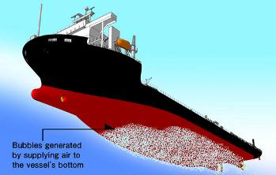
Figure 1. Air Lubrication System for tankers
The air bubble distribution across the hull surface reduces the resistance working on the ship’s hull, creating energy-saving effects. With the right ship hull design, the air lubrication system is expected to achieve up to 10-15% reduction of CO2 emissions, along with significant savings of fuel. Silverstream Technologies has installed their air lubrication system- Silver stream System on the vessel of Norwegian Cruise Line. It is the first commercial installation for improving operational and environmental efficiencies as a means of reducing emissions, fuel costs, and improving the sustainability of their operations. The Silver stream System produces a thin layer of micro bubbles that creates a single ‘air carpet’ along the hull of the vessel. This reduces the frictional resistance between the water and hull and improves the vessel’s operational efficiency, reducing fuel consumption and associated emissions. The technology can be added to a new build design, or retrofitted to an existing ship within just 14 days.
- PRACTICAL CASE STUDY MADE ON AIR LUBRICATION TECHNOLOGY:
- OUTLINE OF HULL BEING TESTED
The outline of the module carrier that was actually used is shown in Table 1. The feature of the carrier is a wide and shallow draft watercraft with a large B/d, so that it has a large flat area in the bottom. The main engine is a medium-speed diesel engine and the propulsion plant has two engines and two shafts with a Controllable Pitch Propeller (CPP). In order to cover the bottom of the carrier with air bubbles, three air blow-off portions are installed on the bottom and the air is supplied by two sets of air blowers that are placed in the auxiliary engine room.

- OBSERVATION OF THE AIR BLOW-OFF CONDITIONS BY IMAGE FROM BOTTOM CAMERA
The air blow-off conditions under sail were photographed by a bottom camera to observe them. Figure shows one example of the air blow-off conditions. It is seen that air blown off from the apertures on the bottom of the carrier turns into air bubbles by tearing-off forces of the surrounding flow of sea water, running in the direction of the stern.
Figure 2. Air blow-off conditions of actual hull experiment. It is seen that the air from the apertures turns into air bubbles, running backward.

- PARTICULARS FOR CONDUCTING ABOVE CASE STUDY ( DIMENSIONS OF VESSEL ):
Table 1.
Carrier Length Loa | 162m
Carrier width B | 38m
Depth D | 9.0m
Draft d | 4.5m/6.7m
Displacement Δ | 10,201 t/19,818 t
Main Engine - | DAIHATSU 6DKM-36 x2 , Max.3 , 218kW x2
Propeller - | CPP
Designed speed U | 13.25 kt
- EVALUATION OF THE ENERGY-SAVING EFFECT
After a normal speed trial test without discharging air, the same speed trial test with air discharged was carried out to measure the energy-saving effect. The speed was compensated by wind and tidal correction and the horsepower of the main engine is calculated from the readings of a load indicator. In a test run, a Togino torsion meter was temporarily installed to simultaneously measure shaft horsepower. Valve openings during the test were restricted based on the results of the wharf wall test. The speed trial test was carried out varying air blow-off rate in three cases. The air supply rate was calculated, with the equivalent air thickness that is defined in eq. (1) taken as 5mm and 7mm, where tb is the equivalent air thickness at the bottom of the carrier, Qa is the air supply rate, Ba is the width covered by air bubbles and U is the ship speed.
t_{b} = $\frac{Q\text{a}}{Ba.U}$ ...eq. (1)
Figure 2. Speed Trial Graph
The Speed trial graph shows the speed trial test results. In the speed trial test of the carrier, the net energy-saving effect was calculated by subtracting the electric power consumption value of the air blowers from the reduction value of horsepower at the time of air blow-off navigation. The results are summarized in Table 2. According to the relationship between speed and horsepower in the speed trial test run, the horsepower appeared to decrease at the time of air blow-off navigation and the speed appeared to increase. In addition, in parallel with the increase of air thickness, the improvement of the net energy-saving effect was confirmed; twelve percent in the case of an air thickness of 7mm, ten percent in the case of 5mm.
Table 2. A comparison of the energy-saving effects from several tests by air lubrication method
Layer Thickness | Horsepower Reduction | Blower electric power consumption | Net energy-saving effect
7mm | 680kW | 211kW | 469kW (12%)
5mm | 530kW | 143kW | 387kW (10%)

CONCLUSION OF THE ABOVE CASE STUDY:
The skin friction resistance of the carrier decreased through the use of an air lubrication method, which is thought to act to decrease the load of the propeller. The carrier is equipped with CPP, so that further improvements in efficiency can be anticipated by re-adjusting the pitch angle of the propellers. And they are planning to conduct various measurements and a verification of the system in a speed trial test. In addition, they are planning to successively carry out the measurement of various data and the adjustment and improvement of the energy-saving effect on actual vessel navigation.
2. Fuel saving propeller attachment:
Hyundai Heavy Industries (HHI) has used an energy-saving device called Hi-FIN attached at the hub of the ship propeller, which generates countering swirls that offset the swirls generated by the propeller, and thus improves propulsion efficiency.
According to an year long trail of the energy-saving device installed on a 162,000 m3 LNG carrier, HHI found that Hi-FIN can save up to 2.5 % of fuel in comparison with the same type of vessels without Hi-FIN. If the fuel saving ratio is calculated on the basis of an 8,600 TEU containership, the owners or operators of the containership can save about $750,000 per year or $19 million for 25 years, an estimated lifetime of the ship.
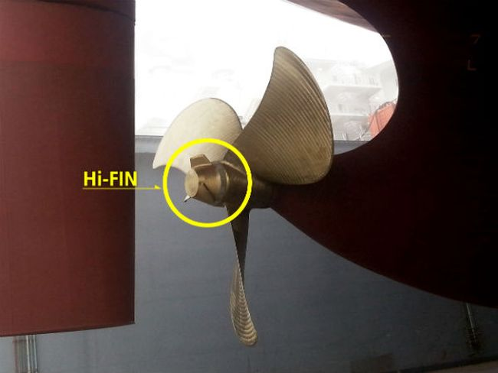
HHI has won orders of Hi-FIN for over 30 ships to date, and the company expects more orders now that it can install the device on broader types of ships from LNG carriers to almost all types of ships including VLCC, LPG carriers and containerships.

3. Nose Job – Modifying Ship’s Bulbous Bow:
Modifying ship’s bulbous bow is an efficient way to reduce fuel consumption of ships. Companies like NYK group and Maersk line has used this technique successfully to improve fuel consumption.
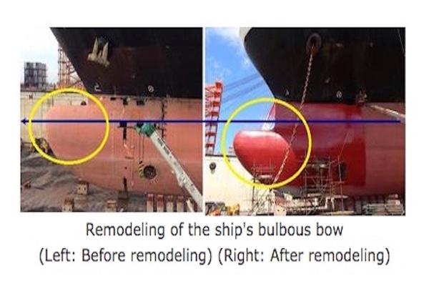
Figure 3. Remodeling of the ship’s bulbous bow
NYK group has made bulbous bow energy-saving adjustments to a containership resulting in a verified 23 percent reduction in carbon dioxide (CO2) emissions over half a year, whereas Maersk group was able to reduce fuel costs by approximately 8 percent in the current slow-steaming environment. The Clipper group was also able to get significant fuel savings with the same method. DNV also carried out a comprehensive study to develop a new bulbous bow shape optimized for the expected trading conditions. After the planned “nose job” in dry dock, onboard measurements showed reduced fuel consumption by almost 1,000 tones per year.
- OPTIMIZATION FOR COST REDUCTION IN LSFO:
As prices of low sulphur fuel oil are more, most of companies prefer high sulphur fuel oil. The high sulphur fuel oil contains more than 0.1% of sulphur these are not allowed to use in SECA areas as pollution is created. Therefore most of the shipping companies optimize new developed technique to reduce sulphur emission from combustion of high sulphur fuel oil and prevent pollution.
Following are the methods and technologies used to reduce sulphur emission from marine engines.
1. Exhaust Gas Scrubber Technology: The exhaust gas from the engine is passed through the scrubber tower where a liquid is showered over it. Fresh water blended with caustic soda (NaOH) is used as a scrubbing liquid which reduces the Sox to 95%. The scrubbing water is then sent to a water treatment effluent emulsion breaking plant after which it can be discharged overboard.
ALPHA LUBRICATION TECHNOLOGY:
Economical consideration includes not only cost of fuel but cost of lube oil takes also. Most of the new modern developed vessels had adopted the “ALPHA LURICATORS” technology.
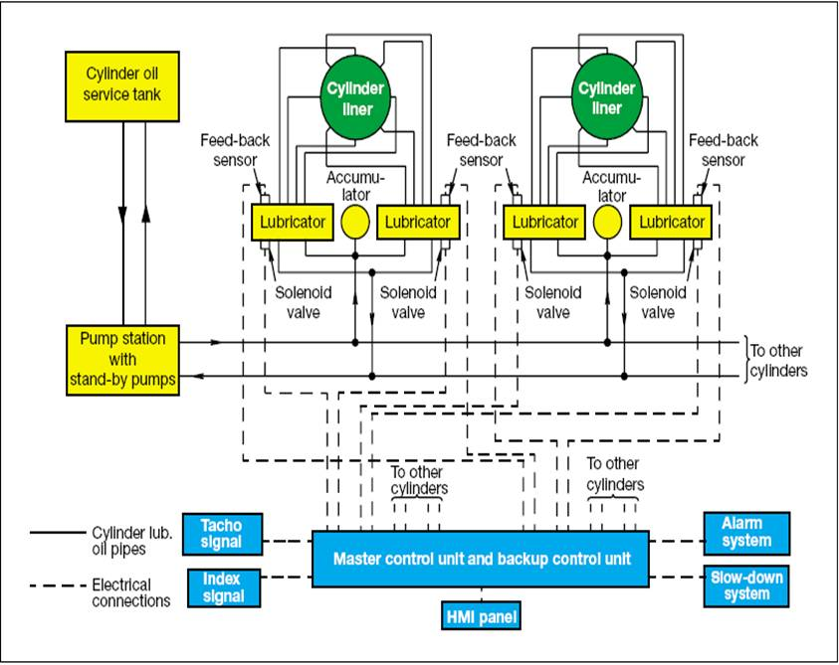
Figure 4. ALPHA CYLINDER LUBRICATION TECNOLOGY
- WORKING PRINCIPLE
A new lubrication system was derived to supply maximum volume of oil between the piston rings. The new lubrication system is given by a unit currently called the “Alpha lubricator” which is also the trade name. In this paper, the system is called the “High speed lubricator”.
The high speed lubricator supplies more oil between the piston rings than conventional lubricator by the lubrication system given below.
A single lubricator unit has five or six plungers, which plungers are driven by a single hydraulic piston. If every cylinder has seven or more lubrication openings, two of the lubricator units are installed. The hydraulic pressure is controlled by solenoid valves. A portion of the return oil is fed to the plunger barrel via a slit for succeeding oiling cycle. Accordingly, the working oil is the cylinder oil .The whole system is controlled by Cylinder Control Unit which calculates the injection frequency on the bases of engine speed signal given by tacho signal and the fuel index. The cylinder lube oil consumption in ME type engines with electronic lubricators, has come down to 0.7 gm/BHP hr.

- PRACTICAL CASE STUDY ON ALPHA LUBRICATION SYSTEM PERFORMED BY MAN B&W ENGINE MANUFACTURER:

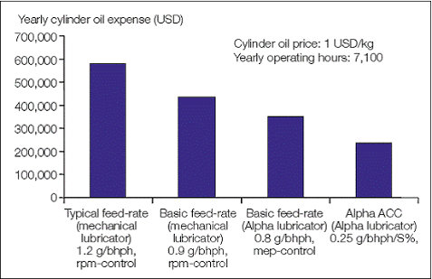
Figure 5. Prize Reduction with alpha lubricator

- RESULT OF CASE STUDY:
Alpha ACC is currently being tested in a large-scale in-service test on a wide range of different MC/MC-C engines. The preliminary test results are very promising with respect to savings on cylinder oil, impact on, in particular, particle emissions and combustion chamber wear figures. Alpha ACC can be implemented for all MC/MC-C engines equipped with the Alpha Lubrication System. As a retrofit on vessels in service, the Alpha Lubricator System with Alpha ACC will have a payback period of less than two years on most types of MC/MC-C engines.

CONCLUSION

From the above mentioned technique optimized for reduction of fuel oil as well as lube oil consumption are very well equipped and operated on modern sea going vessels. The subject of reduction of SOx emission is mentioned in order to reduce the use of low sulphur fuel oil because these oils are costly. Hence these methods do not completely minimize use of LSFO but plays a major role in optimization. Therefore optimization is essential in every aspect because cost matters the most.

“OPTIMIZATION IS THE KEY FACTOR FOR SAVINGS”

REFERENCES

1) ALPHA ADAPTIVE CYLINDER OIL CONTROL ALPHA ACC BY MAN B&W
2) MITSUBISHI HEAVY INDUSTRIES TECHNICAL REVIEW VOL. 47 NO. 3 (SEPT 2010)
3) MARINE DIESEL ENGINES BY A.J. WHARTON

