“CONCEPTS ON ANTI-PIRACY MEASURES”

INTRODUCTION:
Over the past decades there have been significant advances in the field of the marine diesel engines. For a number of years, in the international shipping, we have been only concerned about marine pollution issues, safety of the vessel, etc. and we as the seafarers had not bothered about the safety of the lives and that of the ship from the hands of the sea pirates. Piracy had become a great hinder to the international shipping industry. Pirates have been around longer than ocean trade routes have existed. Piracy has been growing tremendously alongside the shipping industry. In this article we going to deal about some of the measures to control anti-piracy and some concepts on the anti piracy weaponry that can be used onboard ship.

WHAT IS PIRACY?
"Piracy is the act of boarding any vessel with intent to commit theft or any other crime, and with an intent or capacity to use force in furtherance of that act." Piracy is committed by private parties that engage in acts of robbery and/or criminal violence at sea. As we head towards 2010, it is clear that piracy remains a clear & present danger to all those who navigate our oceans. Attacks are on the increase – even though global naval forces are deploying impressive fleets to combat this ancient trade: hijacks & kidnapping that often result in multi-million pound ransoms.

DAWN OF PIRACY ERA:
Pirates are concentrating more in developing and struggling nations. Moreover, in recent days there are only very few number of crews boarding on the vessels. This makes a one of the most favourable reason for the pirates.
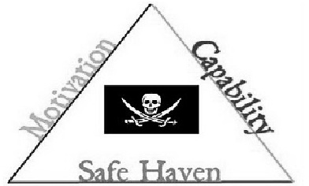
THE PIRACY TRIANGLE:
Figure 1: PIRACY TRIANGLE
Piracy is a product of three causative factors:
- Motivation for gain,
- Ability to project an armed force with the capability to seize vessels in shipping lanes, and
- Safe havens pirates can use for home bases from which they can market their loot.
Remove or interrupt any one of these factors and piracy is eliminated or reduced.

MODERN PIRATES TECHNOLOGY:
Modern pirates also use a great deal of technology. It has been reported that crimes of piracy have involved the use of
- Mobile phones,
- Satellite phones,
- GPS,
- Sonar systems,
- Modern speedboats,
- Assault rifles,
- Shotguns,
- Pistols,
- Mounted machine guns,
- RPG (rocket-propelled grenade)
- Grenade launchers.

ANTI-PIRACY WEAPONRYS:
Combating the threat of pirates is much more difficult than it may seem. Pirates are also heavily armed with A RANGE OF MODERN WEAPON. Unfortunately, modern ship crews do not carry arms because armed vessels are not allowed to dock in many of the world’s ports. The fear is that use of guns by crew members could easily escalate both the violence of these attacks and the harshness of pirate reprisals. Moreover, shooting the "wrong pirate" may cause political, military or legal problems that are simply impossible to solve. We can't even use a cell phone or walkie-talkie on a tanker for fear for making a spark which might explode the vessel.With no arms on board, the crew has no way of defending themselves, for that they rely on the help of local Navies. But the military cannot escort all cargo that passes through these dangerous waters, so a number of non-lethal weaponry can be used onboard.
Some of the non-lethal weapons that can be used as anti-piracy weaponry on the vessels are as follows:
- Remote controlled fire hoses
- Sonic weapons,
- Molotov cocktails,
- Rubber bullets,
- Electric fencing,
- Blinding weapons,
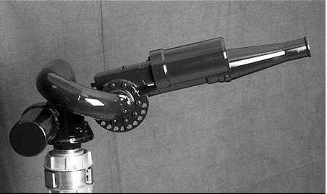
- Pain ray.
REMOTE-CONTROLLED FIRE HOSES:
The most common means of deterring pirates is with the use of firehoses. A ship’s crew will line up on deck, activate the large fire pumps in the engine room and use the pressurized sea water to knock pirates off of boarding ladders. While this is effective it's of little use when the boarding craft approaches with its 50 caliber machine gun armed.
Figure 2: REMOTE CONTROLLED HOSE
But if there were more pirates in other boats aiming guns, the crew would have to give up. To solve the obvious problems of guns against water, we can use remote-controlled high-pressure water cannons that don’t expose the crew to enemy fire.

JET GUN:
This is an innovative water-jet system which defends the vessel against forced boarding by the pirates. It consists of two water jet guns mounted on the shipside, rotating 90 degrees and continuously shooting a high pressure stream of water. It can be installed on all kind of vessels and is especially suitable for oil, chemical, LPG and LNG ships as it is intrinsically safe. This system is easy to install and operate, because it uses the existing facilities of fire fighting pumps, pipelines and hoses. Therefore no additional installation is required onboard the vessel.
Figure 3: JET GUN (HOSE)
The machines using the water pressure from the fire fighting system pre-installed on all ships provides a continuous water curtain along the hull and makes boarding by pirates almost impossible. The system can be operated for an indefinite amount of time and can be started from a safe location within the accommodation. The water pressure being used is of 8~16 bar and the flow rate is about 30~100m³/hr.

ADVANTAGES:
• Easy installation
• Quick operation which is completely safe for crew onboard as the pressure works only along the shipside.
• No further requirement for setting the machine angle or changing the cycle.
• Simple, effective and maintenance free design.
• Continuous repeating cycle without the need to for human intervention.
• Can be installed and used on all kind of vessels safely as is intrinsically safe.
• Option of selecting the various additives for maximizing the effect.

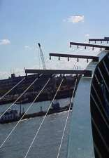
ELECTRIC FENCING:
An electric fence is a barrier that uses electric shocks to prevent unauthorised persons from gaining access to the deck of a ship. A 9000 volt wire fence can be installed around the perimeter of your vessel to repel the pirates away from it. The system would be similar to that of the 5-strand wire outrigger used on the top of perimeter fencing. The Electro-Net would give a short, sharp shock, which has been proved to deter anyone from having a second attempt. Full monitoring facilities would be installed producing an alarm if the system were interfered with by shorting, cutting or reducing the voltage. The Electro-Net could be rolled up and stowed until next required.
Figure 7: ELECTRIC FENCING

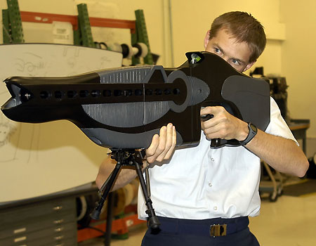
BLINDING WEAPONS:
Figure 8: DAZZLE GUN
This is also known as dazzle gun is developed by the U.S Air Force. A futuristic-looking rifle designed to temporarily blind adversaries who get too close to base. This technology could easily be used by the crew aboard cargo ships.
It is a hand-held, single-operator system for troop and perimeter defense. The laser light used in the weapon temporarily impairs aggressors by illuminating or “dazzling” individuals, removing their ability to see the laser source.

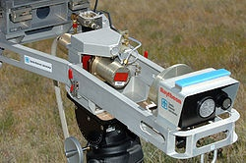
PAIN RAY:
Figure 9: PAIN RAY
Pain ray, also known as Active Denial System (ADS) is a less-lethal, directed-energy weapon developed by the U.S. military. This non-lethal weapon induces a lot of pain by focusing a tight beam of electromagnetic waves on the skin.

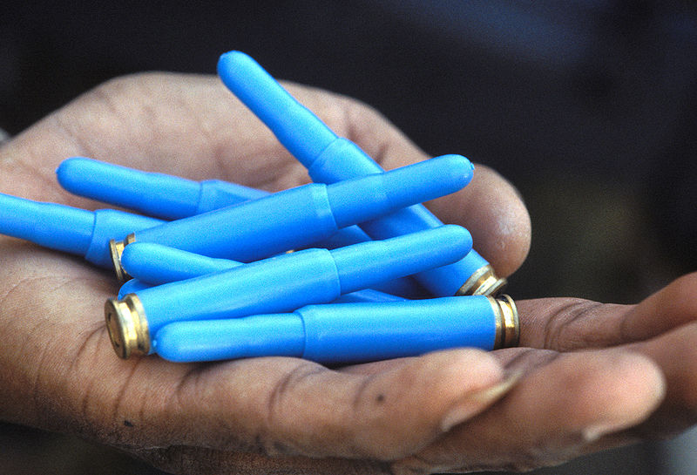
RUBBER BULLETS:
Figure 6: RUBBER BULLETS
Rubber bullets are rubber or rubber-coated projectiles that can be fired from either standard firearm. Like other similar projectiles made from plastic, wax, and wood, rubber bullets may be used for short range practice. Firing rubber bullets at attacking pirates is one of the best techniques; however most rubber bullets today are fired from real guns that are not allowed in most ships. But the crew could use high-powered air guns to fire the bullets; this would certainly cause pain if not serious injury.

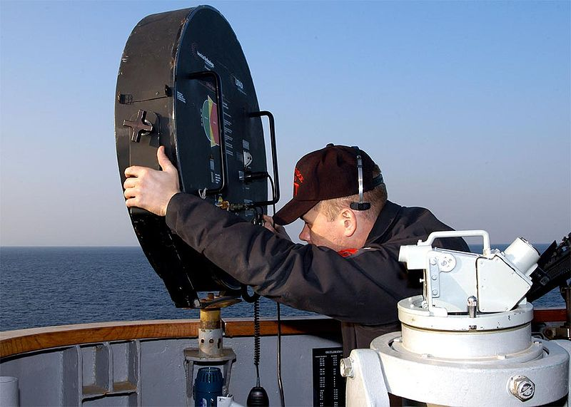
SONIC WEAPONS:
Sonic weapons are weapons of various types that use sound to injure or incapacitate the pirates. One of them is the long range acoustic device (LRAD). The LRAD is designed to emit a painful blast of sound for up to 300 meters away. Its output is up to 155 db, which is sufficient to produce permanent ear damage and temporarily disrupt vision. The possibility of a device that produces frequency that causes vibration of the eyeballs and therefore causing distortion of vision.
Figure 4: LRAD
It may also be used simply as a very effective megaphone prior to any use as a weapon.

MOLOTOV COCKTAILS:
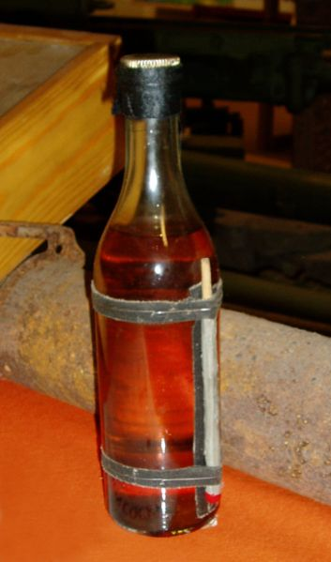
The Molotov cocktail is also known as petrol bomb or gasoline bomb. Due to relative ease of production they are frequently used by non-professionally equipped fighters and others who cannot afford, manufacture, or obtain hand grenades.
They are primarily intended to set targets ablaze rather than instantly destroy them A Molotov cocktail is a glass bottle containing a flammable substance, usually with a source of ignition such as a burning cloth wick held in place by the bottle's stopper. On board ships, Molotov cocktail can be prepared using available fuel and are targeted towards the pirates.
Figure 5: MOLOTOV COCKTAIL

HIGH-TECH ANTI SEA PIRACY SYSTEM:
BAE systems have developed a sophisticated electronic early warning system to combat piracy on the high seas. This system can be used in defence and security to detect suspected pirate vessels at a long range of 25 km. Long range detection gives ship’s crew enough time to take preventive/offensive actions against suspected piracy vessels.
The systems current capabilities include:
  - High Frequency Surface Wave Radar (HF SWR) to detect small boats well beyond the horizon at up to 25 km.
  - Panoramic Area Surveillance System (PASS) 360Â° video camera and display system for visual identification, movement detection, threat level alarms. Integrating with infra-red systems for detection is also being taken up.
  - Passive Radar Identification System (PRISM) to provide early warning of an unidentified radar carrying vessel.
  - Laser Dome: Improved lighting to increase the likelihood of detecting intruders within the immediate vicinity of the ship at night and act as a deterrent.
Fine tuning of the system is being done by coordinating with major ship owners to assess commercial requirements and security agencies so as to bring out the most effective solution to sea piracy.

CONCLUSION:
The number of terror incidents at sea related to the maritime industry may be minimal at this point of time compared to others but we must realize that sooner or later this can change. As we know that “For every action there is an equal and opposite reaction”, pirates keep on developing strongly inspite of finding new technology. We as mariners can take steps to control piracy and cannot completely eradicate them. We may not be able to eliminate the menace totally but all we are trying to reduce the risk. Company and ships better prepared to face the modern day threats of terrorism will benefit ultimately.

