Development of Port & its Socio- Economic Effect on Hinterland
Noise Abatement of Ships in Sorts
1. Akarsh Padiyal, Great Eastern institute of Maritime Studies,
Lonavala, akarshpadiyal@gmail.com
2. Amit C. Gupta, Great Eastern institute of Maritime Studies,
Lonavala, amit6224@gmail.com

Abstract
As per study it has been established that a ship that is in agreement with the external noise limits imposed by the international maritime organisation, IMO, when the ship at berth, potentially can have a significant impact with respect to noise in the surroundings. The noise guiding limits for residential/city areas in the time period 22-07 is 40dB(A). By applying the most simple noise propagation model it is demonstrated that if the sound power is 107dB(A) and the noise limit is 40dB(A), the ship should be berthed more than 600 m away in order not to exceed the noise limit.
Keywords
Noise Mapping; Port Noise; Ports noise reduction; Methods of
reducing noise.

- Introduction
An excerpt of the unattenuated sound powers of some marine diesel engine exhausts and ventilation fans have been presented and found to be quite significant in light of the environmental noise requirements. i.e. the sound power of the engine exhausts vary between 135 to 142 dB(A) and of the ventilation fans between 81 to 110 dB(A).
Noise measurements of secondary noise sources such as reefers, cooling containers, show that the sound power of a single reefer is in the range of 90 dB(A). Each time the number of reefers is doubled the sound power increases by 3 dB. Therefore the noise from reefers can be significant. Standard measures for reducing noise from the major external sources onboard ships have been presented including special noise reducing measures.

The main causes of noise pollution are listed below:
- The extent of the noise problem in ports and surroundings from shipboard noise sources.
- Determination of the main sources that dominate the noise emitted by ships during port condition.
- Overview of the possibilities to attenuate the noise sources with technical solutions. This includes an evaluation of a realistic attenuation and economic cost of the different solutions

- MAIN WORK
2.1 Noise from ships in ports:
Ship operations in ports occasionally cause problems with disturbing noise in nearby dwellings. The rules and regulations of noise from ports have not been as explicit as in other areas of industry and commerce. With the increasing desire for planning denser cities and in particular the demand to convert deserted harbour areas into attractive dwelling areas the need for clear rules has increased. In this context it is important to disseminate information about the relevant noise sources and the possibilities for control of these. In recent years several EU funded projects have been or are being carried out with special attention to harbour noise and noise from ships e.g., NoME Ports (Noise Management in European Ports), and BESST (Breakthrough in European Ship and Shipbuilding Technologies). Therefore, future additional external noise requirements for ships are an obvious possibility.

2.2 Existing legislation on external noise:
The international maritime organisation, IMO, specifies in resolution A.468(XII), Code on noise levels on board ships, a noise limit of 70 dB(A) at listening posts, including navigating bridge wings and windows during the ship’s normal operational conditions. The Danish Maritime Authority has, in addition to the IMO resolution, noise limits and recommended limits at listening posts, external leisure areas and rescue stations stated in their Technical Regulation on Noise in Ships. These noise limits are 70 dB(A) at listening stations and 75 dB(A) at external leisure areas and rescue stations; recommended limits are 5 dB lower. New ships should be designed to have noise levels below the recommended noise limit. These limits restrict the total noise level at listening posts and other positions which indirectly limit how much noise commercial ships may cause in the surroundings.

Equation Maximum allowable noise from the diesel generator exhaust Consider a container ship equipped with one diesel generator and one main engine with exhaust outlets at 20 m distance from a listening post, see Figure 1.

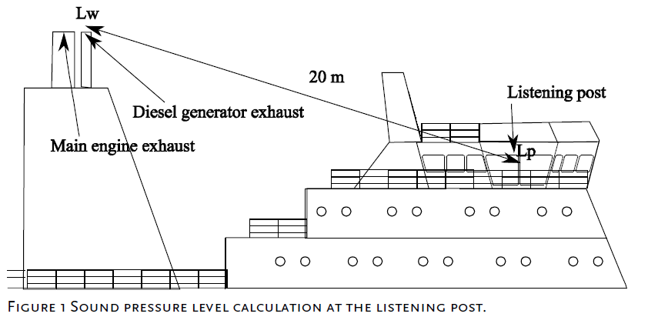

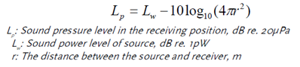
The noise limit at the listening post, as defined by IMO regulations, is 70 dB(A) at a normal sailing condition. This imposes limits on the maximum allowable sound power of the diesel generator and the main engine exhausts. The most basic propagation model describes the sound pressure level at a receiving position at a large distance from a noise source. The equation is shown below:

Noise sources
The primary sources of noise on a ship at berth that give rise to noise in the environment can be divided into three categories:
- Diesel generator engine exhaust
- Ventilation inlets/outlets
- Secondary noise sources, e.g. pumps, “reefer” refrigerated containers

2.3 Possibilities for noise reduction:

2.3.1 Diesel generator exhaust

- Silencers

On the majority of larger ships silencers should be included in the exhaust stack of the diesel engines to fulfill the external IMO noise limits. The needed noise attenuation of a silencer should be determined by thorough calculations taking the type of engine, design of the exhaust stack, external noise limits and other relevant factors into consideration. Three different types of silencers are shown:

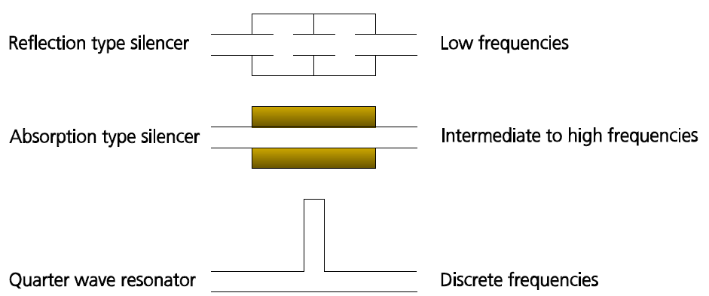

Conventional engine exhaust silencers are of the reflection type, absorption type or a combination of these two. The reflection type silencer is used for attenuating low frequencies. The absorption type attenuates the intermediate to the higher frequencies. The complete frequency range can be attenuated by a combination of the two.
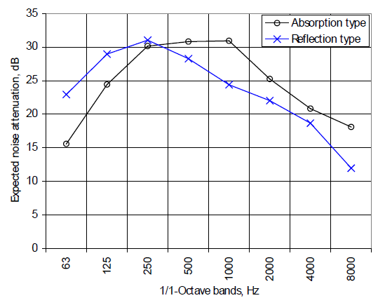

- On shore power
Onshore power supply for the vessels during berth is another option that eliminates the need for power generation onboard. The noise from the diesel generator is thereby eliminated and the need for engine room ventilation is reduced. Engine room ventilation noise is therefore also expected to decrease. According to ports are not normally prepared for supplying power to vessels and many vessels are not prepared for onshore power supply.
There may be technical difficulties in establishing on shore power and there are no standard for the power used on board ships i.e. voltage and frequency, but standardization is in progress. Ships that are obvious to consider for on shore power supply are ships frequently calling ports (such as ferries), with long port stays (such as bulk carriers), with high noise levels or with tonal content in the noise. Establishing on shore power is considered as a large investment. The noise reduction potential is however significant.
2.3.2 Ventilation
- Standard silencers
Noise reducing measures for ventilation systems are less costly compared to decreasing noise from diesel generators.
Various ways of attenuating noise from different ventilation systems exists. Below figure shows a hold ventilation fan room with some of the different possibilities for attenuating the noise from the ventilation fan.
The most inexpensive way of reducing ventilation noise is to install mineral wool in the fan room or the ventilation ducts. The mineral wool increases the sound absorption in the room and in the ducts. The mineral wool is normally covered with thin perforated steel plates, glass cloth or similar. The covering should be porous. Depending on installation details and properties of the mineral wool 10-15dB noise reduction can at best be achieved.
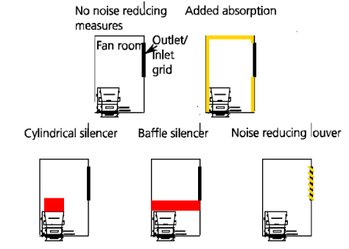

2.3.3 Secondary noise sources
In some cases secondary noise sources such as compressors, pumps etc. can be a significant contributor to the noise emitted from the ship to the surroundings. Different solutions for decreasing the noise exist depending on the specific noise problem. E.g. if a pump is rigidly mounted on a ship the large ship-structure helps radiating the structure-borne noise introduced by the pump. By resiliently mounting the pump the acoustic coupling between the pump and the ship-structure is minimised and the noise caused by the pump is reduced. If the problem is mainly airborne from the external machinery an acoustic enclosure can be engineered.
2.3.4 Other noise reducing measures
The noise emitted from a ship is in some cases asymmetric. The ship can therefore advantageously be berthed with the less noisy side facing the noise sensitive areas in the harbour. Another similar option is to require that ships provide data on measurements of the noise radiated to the surrounding before calling at a port. In this way the noisiest ships can be berthed furthest away from residential and noise sensitive areas. This could further be implemented by using an economical incentive for reducing the external noise from the ships. E.g., ships calling at a port without information on the noise emitted to the surroundings, or with high noise source levels, could be charged with an increased fee for berthing. Another option is to enter a dialogue with the ships in order to explore if the operational time of different ventilation systems and other machinery could be decreased. In some container terminals it may also be possible to rearrange containers and similar moveable equipment to screen noise sensitive areas from the ships.

- CONCLUSIONS: – NOISE REDUCTION
Figure below shows a diagram of different solutions to different external noise problems and a ranking of the cost of the solutions. The diagram is based on the major sources of external noise on board a ship during port stay. Each of the solutions is assigned with a colour a letter defining the approximated cost. Red colour and the letter C indicates that the implementation of the solution is evaluated as being cumbersome, time-consuming and expensive. Yellow colour and the letter B indicates that the cost of the solution is estimated to be in the intermediate range i.e. that the solution can be implemented with less structural changes to the ship, that it is less time-consuming and is less expensive. Green colour and the letter A indicate that the solution is the least cumbersome to implement, the least time-consuming and estimated as the least costly of the presented solutions. Reducing noise from diesel generators will often require major structural changes to the ship e.g. installing new silencers. Structural changes of this magnitude are performed at a shipyard which is considered costly. Whereas, installing mineral wool in a fan room is simple and can be carried out by the ship’s crew or a contractor during port stay. A noise reducing measure on this scale is therefore considered less costly.
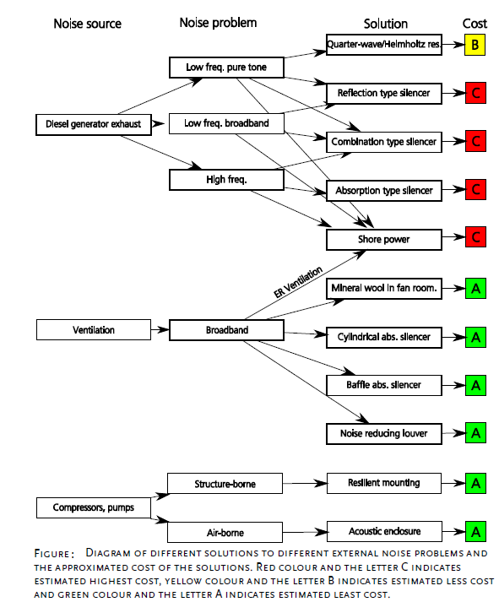

ACKNOWLEDGEMENT:
- Great Eastern Institute of Maritime Studies
- Tolani maritime studies. Thanks for giving a platform for exploring our ideas
- Mr. Ajoy Chatterjee – Principal and head , GEIMS.
- Captain Ravi Shankar - Vice- Principal , GEIMS.
- Mr.M. Patrao, C/E - Course Ordinator GEIMS (ETO)
- Mrs. Meena Ravishankar – Soft skill Trainer.
- All other faculties

REFERENCES:
- Breemen, Ton Van, NoMEPorts, “Good Practice Guide on Port Area Noise Mapping and Management”
- IMO Resolution A.468 (XII), ”Code on noise levels on board ships”, 1981
- IMO Resolution A.343(IX), “Recommendation on methods of measuring noise levels at listening posts”, 1975.
- CadnaA software - http://www.datakustik.com/
- http://www2.mst.dk/udgiv/publications
- www.google.co.in

