OPTIMIZATION OF HYDROGEN DI ENGINE TO REDUCE NOx EMISSIONS

Md. Asif Chand , Rishabh Monga
Mechanical Enginnering, 3rd Year, VIT University, Chennai Campus

ABSTRACT
A DI engine with split injection is proposed which provides the following benefits:
- The direct injection prevents the risk of backfire in the intake manifold as the intake valve closes before the start of injection of fuel directly into the combustion chamber.
- Split injection provides enough time for the homogenous mixture formation.
The proposed research work would be based on the CFD simulations using ANSYS FLUENT software. In this work, injection timing is optimized and the fuel quantity injected at each injection, such that peak temperature is low to prevent the pre-ignition and also to reduce the NOx emissions.
Keywords: PFI (Port Fuel Injection), DI (Direct Injection), CA (Crank Angle), BTDC (Before Top Dead Center), CFD (Computational Fluid Dynamics)
- Introduction
Due to the increasing rate of global warming due to gases like carbon dioxide, and the depletion of the conventional natural resources, there is a need of sustainable development and use of alternate sources of energy. In this regard, Hydrogen fuel is considered as a potential source of energy for the coming future because of its zero emissions of carbon dioxide and abundant supply in nature. It can be used as a conventional fuel in the IC engines without any major changes in the engine design itself.
External mixture formation (PFI) entails some benefits compared to internal mixture formation (DI) [1][3][4][7], higher engine efficiency, lower NOx production, extended lean operation, lower cycle to cycle variation. These are the consequences of higher mixture homogeneity due to longer mixing time for PFI and to the turbulence the mixture acquires passing through the intake valves. Nevertheless, some recent studies show that an optimized DI system that allows proper mixture stratification around the spark plug improves efficiency, reduces cooling losses, extends lean operation, and reduces cycle to cycle variation [2][6].
However, there are some technical issues associated with it in its use in IC engines including chances of backfire at high loads, pre-ignition due to hot spots and the excessive NOx emissions at high temperatures, as N₂ reacts with O₂ at temperatures greater than 1800K to form NOx. Most modern fuel metering systems deliver fuel and air separately to the combustion chamber. Thus hydrogen can be added to the air mixture at a point where condition for pre-ignition are less favourable.
The high flame speed and wide flammability range of hydrogen mixtures allow very lean operation with important benefits on efficiency and NOx control. NOx production is very low for φ<0.45 (the so called “mixture formation limit”), thus a quality based mixture control can be used as far as the load is compatible with this limit. At heavier loads, throttle stochiometric operations becomes mandatory to enable the use of catalytic converter for NOx reduction [5]. It is worthwhile mentioning that a deoxidizing catalyst is very efficient in this application, because hydrogen that remains in the exhaust gas at φ=1 is a highly efficient reducing agent. To avoid throttling and consequent pumping losses that reduce indicated efficiency, load control can be based on EGR (0-50%) addition to stochiometric mixture, by recycling exhaust gas in a proportion depending upon power demand.

- CFD Predictions
3D CFD simulations are a very powerful tool for the development of IC engines that helps IC engine developers to understand complex incylinder events occurring in modern combustion systems. As well as concerns hydrogen DI engines. CFD allows getting deeper insight in mixture preparation process that is a key issue. All the H2-DI CFD studies in literature concern high pressure gaseous injection with high pressure ratios.
Our CFD study is based on ANSYS FLUENT 13.0, a CFD finite volume code concerning chemically reacting turbulent flows in internal combustion engines. Turbulence is modeled using k-episilon approach. A User defined fuction(UDF) file concerning the details of the initialization, injection timing and quantity of fuel injected was uploaded and compiled to get the necessary boundary conditions for the system. The computational grid has been shown below. Taking the advantage of engine symmetry, only a sector of combustion chamber was studied.
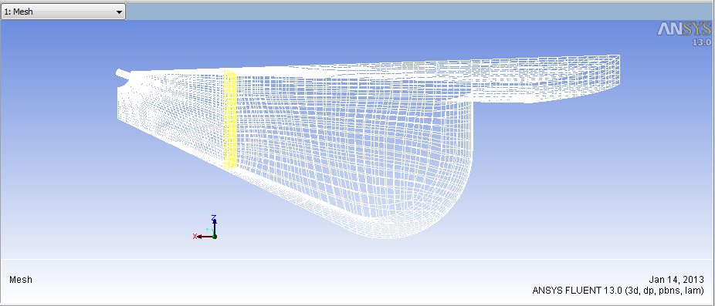


Figure 1: sector of the Combustion Figure 2: Mesh for the Combustion
Chamber Chamber

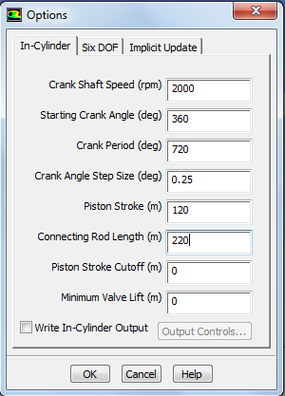
Figure 3: Incylinder options for Combustion Chamber

It should be noticed that hydrogen sonic velocity is above four times the sonic velocity of air. Therefore, in order to improve calculation accuracy, small size cells were required in the region around the hydrogen valve where huge flow velocities occur. A compromise is advisable between small cell size local requirements and containment of the overall cell number.

Initially hydrogen was injected in a single direct injection in the combustion chamber, and simulations were done at various crank angles to reduce the higher temperature pockets as much as possible, which subsequently reduces the NOx emissions.
Analysis were performed at the both inlet and exhaust valve closed (during the compression stroke), in order to reduce the computational time required for analysis. Inlet valve closed also eliminates the chances of intake manifold backfiring due to the high combustion chamber temperature. The gauge pressure and temperature at the initial stage of analysis was taken to be 1898675Pa and 690K respectively. Higher initial temperature is required since the auto ignition temperature of hydrogen is high (773.15K). This can be attained by using a glow plug, heat generated by the glow plugs is directed into the cylinder, and serves to warm the engine block immediately surrounding the cylinder.
Injection was done at three different CA- 20⁰, 27.5⁰, 30⁰ BTDC. The contour plots for the temperature distribution of the respective CA in the combustions chamber are shown below.

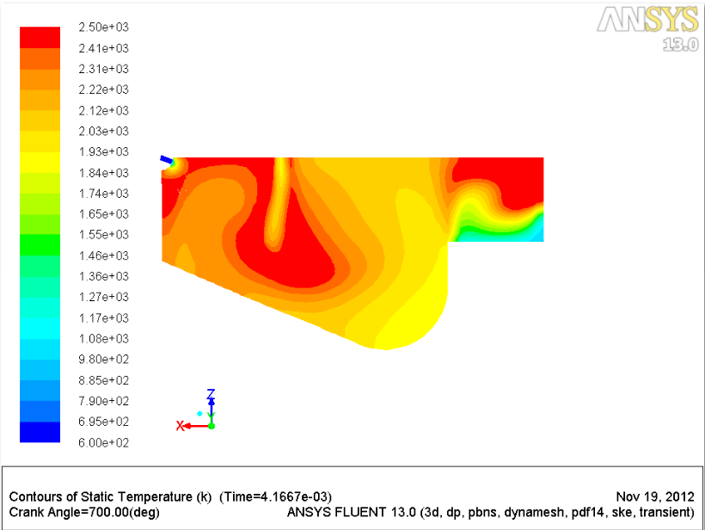
Figure 4: Temperature contour at 20⁰BTDC

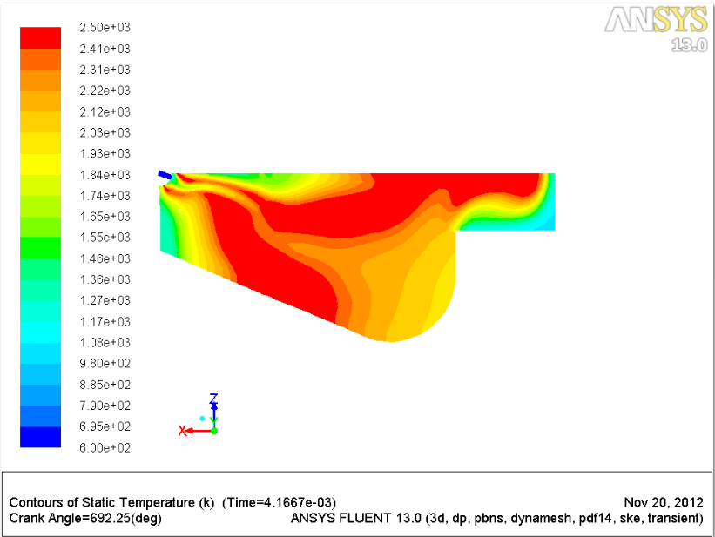
Figure 5: Temperature contour at 27.5⁰BTDC
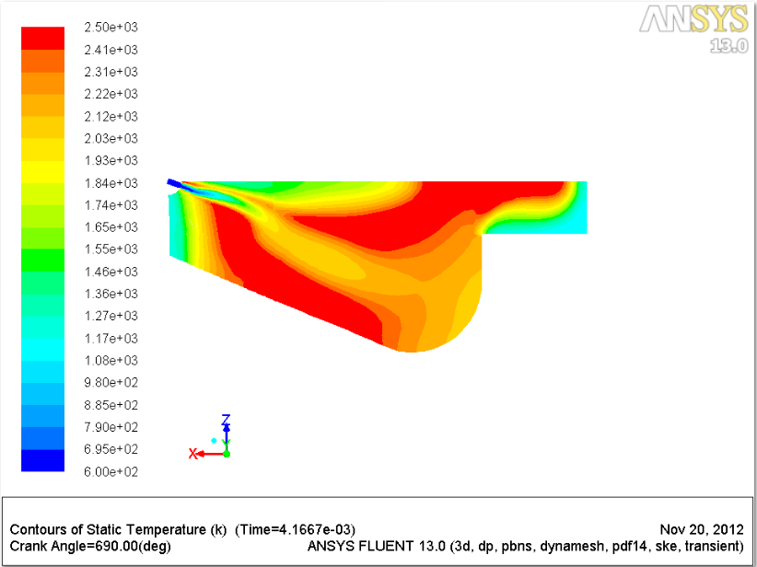
Figure 6: Temperature contour at 30⁰BTDC

It can be inferred from the plots that the maximum temperature pockets (red plots corresponding to 2500K) are relatively higher corresponding to 30⁰BTDC and least in 20⁰BTDC. The results can be justified because the more we give the time for mixture formation before combustion, the better the combustion takes place due to proper mixing and thus higher would be the peak temperature distribution. Also early injection may lead to pre-ignition phenomena at high loads. At the same time, for 20⁰BTDC, there would not be enough time for proper air-fuel mixing resulting in improper combustion that leaves a lot of unreacted hydrogen. Thus the optimal injection timing was found to be 27.5⁰BTDC.

Drawbacks of single injection of fuel
In a single injection, the auto-ignition cannot be optimized due to poor mixing rate of hydrogen-air, which leads to increased knocking tendencies.

- REMARKS AND CONCLUSIONS
The studied hydrogen injection system gives us the following benefits:
- Typical advantage of the direct injection (high specific power and no backfire).
- Reduction of NOx emissions by varying the injection timing.
- Improved efficiency, reduced cooling losses, and extended lean operation.
Further improvement in the model can be performed using split injection of the hydrogen which involves injecting hydrogen partly in two intervals which will have the following benefits:
- The first injection involves only a small amount of hydrogen injection in the combustion chamber that results in a homogenous air-fuel mixture formation. Because of this early initial injection, even at high loads, satisfactory mixture homogeneity is achieved at the ignition time.
- The second injection involves injecting the remaining quantity of hydrogen in the combustion chamber that initiates the combustion.
- This split injection will further reduce the NOx level and the heat release rate.

- REFERENCES
[1] Berckmuller M. et. al., 2003: “Potential of a charged SI-hydrogen engine”, SAE paper 2003-01-3210
[2] Grabner P., Eichlesder H. Gerbig F., Gerke U., 2006: “ Optimisation of a Hydrogen internal Combustion Engine with Inner Mixture Formation”1st, Graz September 28-29, 2006
[3] Lee J.T., Lee C.W., and Caton J.A., 2000: “An investigation of a cause of backfire and its control due to crevice volumes in a hydrogen fueled engine”, ASME Spring Technical Conference, paper 2000-ICE-284, San Antonio, USA , 2000
[4] Natkin R.J. et. al. Hydrogen 2003: “IC engine boosting performance and NOx study”, SAE paper 2003-01-0631
[5] Rottengruber H., Berckmuller M., Elsasser G., Brehm N., Schwarz C., 2004: “Direct-Injection Hydrogen SI-Engine-Operation Strategy and Power Density Potentials”, SAE paper 2004-01-2927
[6] Shudo T.,2007: “Improving thermal efficiency by reducing losses in hydrogen combustion engines”, International Journal of Hydrogen Energy 32 (2007) pg. 4285-4293
[7] Tang X. et. Al., 2002: “Ford P2000 hydrogen engine dynamometer development”, SAE paper 2002-01-0242

