“AUTOMATED ENGINE MONITORING SYSTEM”
- MAXIMIZING PERFORMANCE
CADET -PRAVEEN.R.SANDEEP &CADET- BHAWANI SINGH , PRE FINAL YEAR MARINE
NOORUL ISLAM UNIVERSITY, KANYAKUMARI.
E-mail: praveen.mariner7@gmail.com
NOTE: VIDEO CAN BE SHOWN DURING THE TIME OF PRESENTATION

ABSTRACT:

The advancement of science and technology has made it possible today, for seafarers to ease their workload and lead a life of convenience onboard. Engine performance monitoring systems collect data with the help of various strategically placed sensors. The shipping industry in general is not very responsive to change. It tends to play safe and rely on hands-on approach to management and operation, in spite of reliable technology having made inroads into and been integrated with safe ship operations. The reasons for inhibition are varied and justified. Shipping along with being one of the oldest trades of the world also carries the baggage of high capital risks in cases where things do not go as planned. Ship owners more often than not are reluctant to invest in technology and believe in time tested methods of human interventions. Investment in shipping has traditionally been pulled by factors such as risk and investment sharing, economies of scale, cost-control, frequency of transportation and the globalization of trade. Although these are still valid factors, the necessity to innovate in order to create competitiveness has become a more and more important factor driving owners to revaluate their stand on technological intervention in vessels. There is no doubt that the shipping industry will face major challenges in the years to come.

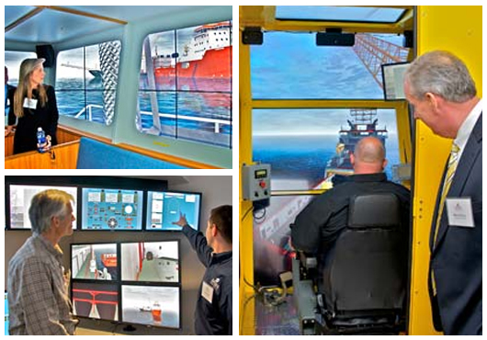

INNOVATION CONCERNS CHANGE

AND

‘WHAT ‘S NEW????????

HERE IS THE SOLUTION MADE BY “KONGSBERG”

AUTOMATED ENGINE ROOM- MAXIMIZING PERFORMANCE

INTRODUCTION:

ENGINE MONITORING SYSTEMS- “UNIQUE ENGINE PROTECTION”
Engine Monitoring Systems consist of bearing monitoring components covering Bearing Wear, Water in Oil, Temperature of all bearings and additional measuring points such as Cylinder liner and exhaust gas temperature.
Software & system components are common with the K-Chief 600 marine automation system and the AutoChief® C20 propulsion control system, allowing integration and joined support. Data transfer via CAN bus forms the bases for easy communication with other KONGSBERG systems
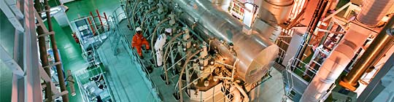

MODULAR AND SCALABLE CONCEPT
Systems may easily be extended by adding additional hardware units such as operator stations, input/output modules and additional measuring points. Kongsberg System Technology offers signal acquisition and processing units for installation in ER cabinets, ECR consoles or mounted directly on the engine. Processing algorithms are executed within the local acquisition units or in the powerful controller units. By distribution and segregation the consequences of a system fault are reduced and may even be eliminated. The Kongsberg Engine Monitoring Systems concept yields a modular design, where the various modules can be configured and combined to suit individual needs. The individualised Engine Monitoring systems can then be integrated with Kongsberg K-Chief and AutoChief C20 system. Each module is fully compatible with each other and therefore provides seamless information sharing and a consistent operation environment. Essential components such as bearing wear sensors and wireless temperature sensors yield the best results that technology has to offer in terms of reliability, accuracy and durability. By utilizing the CAN field bus protocol for engine instrumentation, installation costs are reduced and the quality of data processing enhanced.

AVOIDING OPEN UP INSPECTION
The Kongsberg Bearing Wear Monitoring System - BWCM is designed according to the specifications of MAN Diesel and Germanischer Lloyd (GL). The BWCM system is one of the required systems in order to avoid open up inspections. The following systems are part of a class survey arrangement:
- BWCM system
- Water in Oil sensor
- Shaft Earthing Device (owner or yard supply)
- Computerized Planned Maintenance System (owner or yard supply)

AVAILABLE ENGINE MONITORING SYSTEMS

BEARING WEAR MONITORING SYSTEM

CROSSHEAD & CRANK TEMPERATURE MONITORING - SENTRY®

CYLINDER LINER MONITORING SYSTEM

MAIN BEARING TEMPERATURE SENSORS

TORQUE & POWER MEASUREMENT SYSTEM FOR ROTATING SHAFTS - METAPOWER

WATER IN OIL SENSOR

ENGINE PERFORMANCE SYSTEM
- BEARING WEAR MONITORING SYSTEM

CONDITION MONITORING OF CRANK-TRAIN BEARINGS IN TWO-STROKE DIESEL ENGINES
The bearing wear monitoring system uses two sensors mounted in each cylinder compartment, measuring every time the crosshead passes bottom dead centre. These sensors perform individual compensations for engine speed, engine crank case temperature and engine deflections due to vessel manoeuvring or cargo loading.
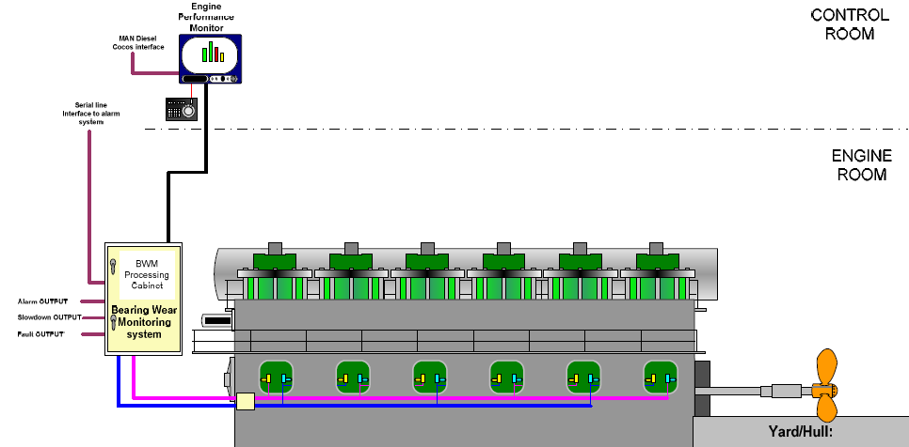

AVOIDING ALL TYPES OF BEARING DAMAGE
Bearing seizures are known to appear in many different forms and are caused by a wide variety of reasons. Combining the bearing wear monitoring system with KONGSBERG's wireless temperature monitoring system (SENTRY) reduces the risk of bearing damages to an absolute minimum.

AVOIDING OPEN UP INSPECTION
The Kongsberg BWCM system is designed according to the specifications of MAN Diesel and Germanischer Lloyd (GL). The BWCM system is one of the required systems in order to avoid open up inspections. The following systems are part of a class survey arrangement:
- BWCM system
- Water in Oil sensor
- Shaft Earthing Device (owner or yard supply)
- Computerized Planned Maintenance System (owner or yard supply)

SYSTEM COMPONENTS
Software & system components are common with the K-Chief 600 marine automation system and the AutoChief C20 propulsion control system, allowing integration and joined support. Data transfer via CAN bus is the base for easy communication with other KONGSBERG systems.
Additionally, other add-on systems are available (see Engine Monitoring Systems).

MAIN BENEFITS
- Significantly reduced risk of unforeseeable repair costs
- Unique long-term measuring accuracy
- Compact and simple installation and cabling on the engine
- Stand-alone or fully integrated with the alarm monitoring system

2. CROSSHEAD AND CRANK TEMPERATURE MONITORING

ULTIMATE EQUIPMENT FOR BEARING TEMPERATURE MONITORING

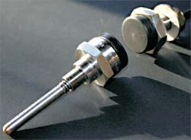
The SENTRY® wireless bearing temperature monitoring system is capable of continuously measuring the metal temperature of bearings during engine operation. Each sensor is individually interrogated from a multiplexed signal processing unit using a high frequency and low energy radar pulse. The radar pulse is transmitted to the wireless sensor via a coaxial cable to a stationary antenna positioned inside the crank case. Within the interrogation range of the stationary antenna the sensor responds to the radar pulse by reflecting a pulse pattern back to the signal processing unit. The characteristics of the reflected pulse is uniquely defined by the temperature.

MAIN BENEFITS
- Significantly reduced risk of unforeseeable repair costs
- Stand-alone or fully integrated with the alarm monitoring system
- Improved operational safety for crew and vessel
- Type approved to replace oil mist detectors
- Compact and simple installation

Main components
- Wireless temperature sensor
- Stationary reading antenna
- Signal processing unit
- CYLINDER LINER MONITORING SYSTEM:

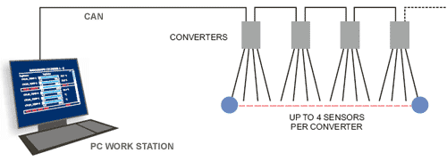
The KONGSBERG cylinder liner monitoring system monitors the piston running performance by measuring the temperature of the upper part of the cylinder liners. Increased friction between the piston rings and the cylinder liner creates an elevated temperature level leading to abnormal liner wear and potential piston ring breakage.
Temperature alarm limits can be individually set on the PC work station to give early warning about high thermal load and potential cylinder liner scuffing. Additionally, individual relay output alarms can be provided directly to the cylinder lubrication units in order to temporarily increase the cylinder lubrication.
The KONGSBERG cylinder liner monitoring system consists of high quality temperature sensors and one field-bus signal converter on each cylinder and one common PC work station.

MAIN BENEFITS
- No more undetected cylinder liner scuffing problems
- Fast and reliable response to operational problems
- Compact and simple installation
- Stand-alone or fully integrated with the alarm monitoring system

4. MAIN BEARING TEMPERATURE SENSORS:
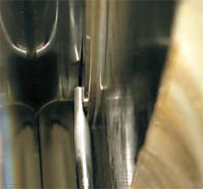
Our custom designed main bearing temperature sensors can be fitted into any type of 2- stroke diesel engines. The sensors are mounted on the main bearing girder with the tip of the sensor in direct contact with the bearing shell. The sensor measures the combined temperatures of the bearing shell and of the lubrication oil that flows from the bearing.

5. WATER IN OIL IN SENSOR/DETECTOR:
The HUMICAP® Moisture and Temperature Transmitter Series for Oil - MMT330 enables fast and reliable detection of moisture/water in oil. The MMT330 can be used in online moisture monitoring and as a control device, allowing separators and oil driers to be started only when needed. Proper monitoring saves both oil and the environment. With the MMT330 it is easy and economical to monitor the effects of moisture in oil.
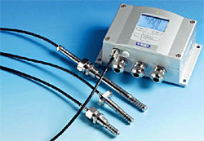

FEATURES
- Dual sensor for continuous measurement of moisture in oil and oil temperature
- Ball valve installation. No need to shut down the process
- Incorporates HUMICAP® Sensor - more than 30 years of field performance
- Ten years of experience in measuring moisture in oil
- Excellent long-term stability
- Easy to calibrate and maintain in the field - compatible with HUMICAP®Hand-Held Moisture for Oil Meter MM70
- Calibration certificate to follow each sensor

RELIABLE HUMICAP® TECHNOLOGY
The MMT330 incorporates the latest generation of the HUMICAP® Sensor, which is the result of ten years of field experience. It was developed for demanding moisture measurement in liquid hydrocarbons. The sensor's excellent chemical tolerance provides accurate and reliable measurement over a wide measurement range.

Indicates the margin to water saturation
The MMT330 measures moisture in oil in terms of the water activity and temperature. Water activity indicates directly whether there is a risk of free water formation. The measurement is also independent of oil type and age.

Water content as ppm conversion
In addition to water activity, the MMT330 can output ppm, the average mass concentration of water in oil. This conversion is readily available for mineral transformer oil. For other oils, the oil specific conversion coefficient can be programmed to the transmitter if the water solubility of the oil is known.

Sensor response time
The water in oil sensor element is made of a polymer where water molecules need time to move to and from the polymer according to the water content in the oil. Response time may therefore be up to ten minutes, dependent of the flow speed of the oil.

6. TORQUE AND POWER MEASUREMENT FOR SHAFTS:
The kongsberg shaft power meter, called metapower® system allows the ship's management to maintain or increase the speed while saving significant amounts of fuel, reducing co² and nox output levels. It measures torque and power transferred from the main engines to the propellers. Comparison between power output and fuel consumption gives valuable information avoiding over-stressing of the engine.
The MetaPower® system measures the RPM (revolutions per minute), torque and power transferred from a ships main engine to the propeller(s).
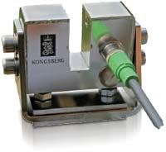

FUNCTION
MetaPower® shaft power meter is a digital measuring system using a laser beam for detection of shaft torque, shaft RPM and consequently the transferred power. The system offers high accuracy and good long term stability. By transmitting measured data via satellite from ship to shore, the shipping company's operation management is able to decide the most economical operating modes for the ship's engine and propulsion system.
MetaPower® can be delivered as a stand alone installation or integrated to KONGSBERG K-Chief automation system or AutoChief C20 propulsion control system.

BENEFITS
The main benefits of the MetaPower® system are:
- Continuous, highly accurate measurements
- Reliable and maintenance-free operation
- Robust construction
- The sensing elements can be installed in hazardous areas
- Suitable for any shaft diameter
- Easy-to-read displays and graphics
- Integration into control and monitoring systems and data networks
- Excellent price/performance ratio
- For shafts rotating at up to 30.000 RPM

WORKING PRINCIPLE
The system is 100% digital, based on measuring with an infrared laser beam guided through fiber optics.
The MetaPower® System measures the twist of a rotating shaft. Two slotted wheels are mounted on the shaft. Light is transmitted by LEDs through the slots in each wheel, converted to a digital electronic signal and sent back to the processing unit for calculation of the corresponding torque. The system displays RPM, torque and power.

Information Provided
The following can be measured and read out:
- Shaft RPM
- Torsional angle between two cuts of the shaft, i.e., the torque
- Power transferred by the shaft

METAPOWER USED ON SHIPS
In July 1999, full scale tests of MetaPower were commenced on board Fjord Line's M/V "Bergen", a passenger and car ferry sailing in a shuttle between Bergen and Hanstholm in Denmark. In October 1999, full scale tests were also initiated on board Solstad Shipping AS' offshore vessel "Normand Progress."
The test programs covered continuous logging and read-out of the propeller shafts' RPM, torque, power and the total energy transferred to the propellers. These logged figures were in turn be compared to the total consumption of fuel in order to optimize the operation of the ship. Both test programs were completed with excellent results.
MetaPower has been installed on board a range of different ship types including passenger vessels, tankers, offshore vessels, cargo/container ships and seismic survey vessels. Ships with both one and two shafts/propellers.
MetaPower is used for many different purposes including optimizing of ship performance, fuel reduction, NOx reduction and to save maintenance costs by minimizing down time. By using MetaPower's additional torsional oscillation analysis, ship owners are able to monitor their propeller shafts and thrusters over periods of time for preventive maintenance and corrective actions.

7. PROPULSION CONTROL SYSTEMS:


LOW AND MEDIUM SPEED, FIXED OR CONTROLLABLE PITCH
AutoChief® propulsion control systems are complete control and safety systems for slow and medium speed propulsion with fixed and controllable pitch propellers. The systems are available for single and dual propulsion lines. They feature a modular design, and can easily be configured for various propulsion configurations. The AutoChief® features the same distributed and fully redundant architecture as our machinery automation systems, with no additional emergency telegraph system required.

SAFETY SYSTEM, K-SAFE:

PURPOSE
Our Safety System K-Safe is a computerised system developed and designed specifically for the safe monitoring and automatic corrective actions in unacceptable hazardous situations. The potential hazard-risks need to be evaluated for any installation. An acceptable risk level must be established and the means to achieve this acceptable risk level must be found.
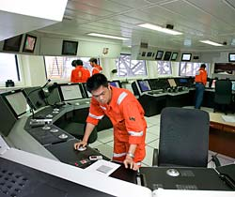

SAFETY SYSTEMS
The K-Safe safety system includes the following:
- Emergency shutdown (ESD)
- Fire & Gas detection and protection systems (F&G)
- Process shutdown (PSD)

HIGH-INTEGRITY
The K-Safe system is a high-integrity system that monitors and protects the installation. It has a success record from numerous vessels and offshore installations throughout the world.

TYPICAL APPLICATIONS
The K-Safe is developed particularly to serve the needs of vessels such as these:
- Drilling vessels
- LNG carriers
- Offshore productions and processing
- Cruise vessels
- Onshore oil and gas terminals
- Offshore oil and gas terminals

8. TANK OVERFLOW PROTECTION:
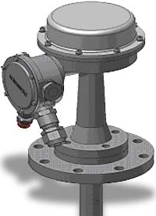

KONGSBERG meets the requirement of major classification societies by offering a radar based Tank Overflow / Overfill Protection System for LNG / LPG cargo tankers.

KEY FEATURES
- No moving parts inside the tank
- Measuring range: 0 to 9 metres
- Accuracy in the whole range: ±7.5 mm
- Continuous level verification - AutroCAL®
- Approved for membrane and spherical tanks
- Pending approval by all major classification societies and measuring institutes
- Rugged modular design
- Ex-classification EEx ia IIC T4
- Individual signal processor for each tank
- Online failure verification
- Alarm for sensor fault, system and power failures
- 3 configurable limits available with visible and audible alarms
- Seagoing mode providing delayed overflow alarm
- Interface to KONGSBERG's Custody Transfer System / Integrated Automation System

Description:
The Overflow / Overfill Protection System is based on our long experience in the Custody Transfer System market. By taking advantage of our technology utilized in our esteemed Custody Transfer System - CTS, we assure high reliability and the best accuracy available in the market. The KONGSBERG system is designed to meet overflow / overfill control requirements from all major classification societies. The system includes level gauges, processing and alarm handling units and a dedicated operator panel. Optionally interface to a KONGSBERG CTS system is available. All equipment on deck is designed for rugged marine environment and manufactured in AISI 316L stainless steel.

9. VESSEL PERFORMANCE SYSTEM:
To optimize the energy consumption of ships, the kongsberg vessel performance system (vps) addresses engine optimization, speed profile, optimal trim, speed and rpm/pitch – to reduce operating costs. The system is installed and proven successful on a variety of ship types.
The Vessel Performance System provides a set of tools that enable ship operators to manage their vessels in a more economical and environmentally beneficial way, all in compliance with the present safety regulations.
The system can be delivered as an integrated part of the K-Chief 600 automation system, or as a stand-alone system, with independent operator stations. The system offers a user-friendly human-machine interface and a practical selection of process pictures.
SYSTEM MODULES
The Vessel Performance System is based on our distributed and modular automation technology and consists of three main modules:
- Fuel Performance Monitoring
- Engine Performance Monitoring
- Energy Management

CONCLUSION:
Thus by using the latest sensors and transmitters, the engine condition can be improved. And opening up of engine for inspection is reduced. The performance of the engine can also be monitored and controlled by computerized system. Hence the performance of the vessel can be maximized.
BIBILOGRAPHY:
  - http://www.km.kongsberg.com
  - www.google.com
  - www.wikipedia.com
  - www.marineinsight.com

