SMART MATERIAL FOR SMART FUTURE
CADET: G.VINOTH KUMAR & CADET: K.SATHEESH BABU
PRE-FINAL YEAR-MARINE DEPARTMENT
EMAIL ID: sailorsatheeshseafarer@gmail.com
PH-NO:-+919488220443

NOORUL ISLAM UNIVERSITY
THUCKALAY, KANYAKUMARI DIST., TAMILNADU

ABSTRACT:

Smart Materials are still at the research and development stage and depend on potential applications to justify further investment in their commercial development. They may provide solutions to existing problems or new technical possibilities that would otherwise not be feasible. Some smart material applications already exist in marine which is generally regarded as conservative in adopting new materials and technologies. Other sectors such as the automotive, aerospace, railway and construction industries are more adventurous and have more experience of smart materials that could be adapted for marine applications. Smart materials considered here are Piezoelectric and Shape memory alloys.

The simplest definition of piezoelectric materials can be obtained by first breaking the word into two ( piezo and electric). Piezo is from the Greek word piezein that means to press tightly or squeeze. Combining piezein with electric we have ‘‘squeeze electricity.’’
Piezoelectric materials generate an electric field along their surface when subject to mechanical stress which are used for Noise, vibration and damping control using variable rate materials in engine and machinery mountings.

Shape memory alloys (SMAs) are metals that "remember" their original shapes. Nickel-titanium alloys have been found to be the most useful of all SMAs. Other shape memory alloys include copper-aluminum-nickel, copper-zinc-aluminum, and iron- manganese-silicon alloys. SMAs are useful for such things as actuators which are materials that "change shape, stiffness, position, natural frequency, and other mechanical characteristics in response to temperature or electromagnetic fields. SMAs are used as vibration absorber and also as shape controller or self repairing.

KEYWORDS:-
Smart materials- Piezoelectric materials, and Shape memory alloy.

NOTE:-
VIDEO CAN BE SHOWN DURING THE TIME OF ORAL PRESENTATION

INTRODUCTION:

The terms ‘smart’, ‘functional’, ‘multifunctional’ and ‘intelligent’ are often used interchangeably. This is reasonable, if confusing, for the first three terms but the last almost certainly suggests a degree of consciousness that does not exist in any non-biological system. There is arguably no such thing as a ‘smart material’ per se - there are only materials that exhibit interesting intrinsic characteristics which can be exploited within systems, or structures that, in turn, can exhibit ‘smart’ behavior. This argument is exemplified by comparing a photo chromic material that changes its color state when exposed to light and a simple metal that changes its physical state when passing through its melting point when subjected to heating.

Smart Materials:
Smart materials are designed materials that have one or more properties that can be significantly changed in a controlled fashion by external stimuli, such as stress, temperature, moisture, pH, electric or magnetic fields. SMART materials are one of the nine network groups operating within the Materials Knowledge Transfer Network (KTN), one of the Knowledge Transfer Networks funded by the Technology Strategy Board.
The more promising applications consideration should be given to:
- Main drivers for new material applications
- Marine applications that could work in both the short and longer terms
- Applications from other sectors where the added stimulus of marine interest could make further development more commercially rewarding
- Priority applications for investment

Marine Applications:

By increasing awareness about smart materials and their potential benefits the aim of this review is to encourage their wider application in the marine industry covering a broad range of potential applications including large commercial ships, offshore structures and recreational craft. The following types of smart materials with some examples of existing uses and suggested applications are as:
- Piezoelectric -Piezoelectric materials are materials that produce a voltage when stress is applied. Since this effect also applies in the reverse manner, a voltage across the sample will produce stress within the sample. Suitably designed structures made from these materials can therefore be made that bend, expand or contract when a voltage is applied.
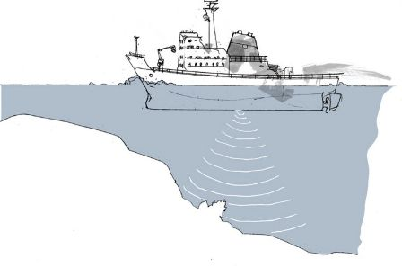 Fig1:-Pieozoelectric transmitter and receiver
- Shape memory alloys -Shape-memory alloys and shape-memory polymers are materials in which large deformation can be induced and recovered through temperature changes or stress changes (pseudo elasticity). The large deformation results due to martensitic phase change.
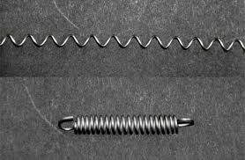
Fig 2:- Shape memory alloy material.
Smart materials have properties that react to changes in their environment. This means that one of their properties can be changed by an external condition, such as temperature, light, pressure or electricity. This change is reversible and can be repeated many times. There are a wide range of different smart materials. Each offer different properties that can be changed. Some materials are very good indeed and cover a huge range of the scales.

Piezoelectric materials:

Piezoelectric materials generate an electric field along their surface when subject to mechanical stress. Conversely, piezoelectric materials show change shape when an electrical field is applied, either as compression or expansion depending on the electrical polarity.
PZT (lead zirconate titanate) and PVDF (polyvinyldene fluoride) have been used either as an actuator or sensor. PVDF exhibits piezoelectricity several times greater than quartz and unlike ceramics, where the crystal structure of the material creates the piezoelectric effect, in polymers the intertwined long-chain molecules attract and repel each other when an electric field is applied. Most of the piezoelectric actuators and sensors either surface bonded or embedded in the adaptive structure system are based on either its extension or shear mechanism.Piezoelectricity (from: pressure electricity) is a property of certain classes of crystalline materials including natural crystals of Quartz, Rochelle Salt and Tourmaline plus manufactured ceramics such as Barium Titanate and Lead Zirconate Titanates (PZT).When mechanical pressure is applied to one of these materials, the crystalline structure produces a voltage proportional to the pressure. Conversely, when an electric field is applied, the structure changes shape producing dimensional changes in the material.

The piezoelectric materials from Morgan Electro Ceramics use polycrystalline ceramics instead of natural piezoelectric crystals. These are more versatile with physical, chemical and piezoelectric characteristics able to be tailored to specific applications. The hard, dense ceramics can be manufactured in almost any given shape or size. They are chemically inert, and immune to moisture and other atmospheric conditions.

In addition to those mentioned above, various sensor applications include:
- Piezoelectric elements are also used in the detection and generation of sonar waves.
- Power monitoring in high power applications (e.g.sonochemistry and industrial processing).
- Piezoelectric microbalances are used as very sensitive chemical and biological sensors.
- Piezos are sometimes used in strain gauges.
- A piezoelectric transducer was used in the penetrometer instrument on the Huygens Probe
- Automotive engine management systems use piezoelectric transducers to detect Engine knock (Knock Sensor, KS), also known as detonation, at certain hertz frequencies. A piezoelectric transducer is also used in fuel injection systems to measure manifold absolute pressure (MAP sensor) to determine engine load, and ultimately the fuel injectors milliseconds of on time.
- Ultrasonic piezo sensors are used in the detection of acoustic emissions in acoustic emission testing.

Shape memory alloys:

Shape memory alloys (SMAs) are alloys that remember their geometry. SMAs produce a significant shear strain, induced by temperature change and are normally made in the form of wire or foil. Their length can be reduced when heated and restored to original geometry by cooling. This is due to a temperature-dependent phase transformation from a low-symmetry to a highly symmetric crystallographic structure which is known as Martensite and Austenite respectively. Martensite is more changeable at the lower temperature phase present in shape memory alloys, whereas austenite is stronger at the higher temperature phase. The nickel titanium alloy (e.g. Nitinol, as for Nickel Titanium Naval Ordnance Laboratory) exhibits strain up to about 8% and will recover its original shape when it is heated above its activation temperature (Dittrich, 1998).
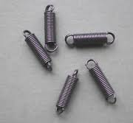

Various shapes of SMA can be used for different purposes; SMA wires can be embedded or attached to host structures as hybrid composites which have a combination of two or more reinforcement fibres or material. Due to the novelty of changing its elastic modulus, SMA could be a vibration absorber, a shape controller and a device for self repairing. Among the major challenges of using SMA is the considerable dependence of the control schemes on external temperatures.
Despite their advantages such as ductility and generating high strain (e.g. 100% for a Shape Memory Polymer), many drawbacks also exist such as slow response, low efficiency, unpredictable movement, only suitable for small-scale applications and continuous high output heat source required so energy consuming.

The shape memory effect in metals is a very interesting phenomenon. Just imagine taking a piece of metal and deforming it completely and then restoring it to its original shape with the application of heat. Taking a shape memory alloy spring and hanging a weight on one end of the spring can easily illustrate this. After the spring has been stretched, heat the spring with a hot air gun and watch it return to its original length with the weight still attached. These materials undergo a thermomechanical change as they pass from one phase to another. The crystalline structure of such materials as nickel-titanium alloys enters into the martensitic phase as the alloy is cooled below a critical temperature. In this stage the material is easily manipulated through large strains with a little change in stress. As the temperature of the material is increased above the critical temperature, it transforms into the austentic phase. In this phase the material regains its high strength and high modulus and it behaves normally. The material shrinks during the change from the martensitic to the austentic phase. The nickel–titanium alloys have been the most used shape memory material.

This family of nickel–titanium alloys is known as Nitinol (Nickel Titanium Naval Ordinance Laboratory), named in part for the laboratory where this material was first observed. Nitinol has been used in military, medical, safety, and robotics applications. Specific applications include hydraulic lines used on fighter planes, medical tweezers and sutures, anchors for attaching tendons to bones, stents for cardiac arteries, eyeglass frames, and antiscalding valves used in water faucets and showers. In addition to the family of nickel titanium alloys there are other alloys that exhibit the shape memory effect. These alloys are silver–cadmium, gold– cadmium, copper–aluminum–nickel, copper–tin, copper–zinc, combinations of copper–zinc with silicon or tin or aluminum, indium–thallium, nickel– aluminum, iron–platinum, manganese–copper, and iron manganese–silicon. Not all combinations of either the two or three elements yields an alloy with the shape memory effect thus it is recommended to review the original literature. In the open literature there are several articles from Mitsubishi Heavy Industries, Ltd. describing the room temperature functional shape memory polyurethanes.

Marine Application:

Ranging from automotive systems, optical systems, machine tools for space systems, medical systems and infrastructures, smart-structures technology is a highly interdisciplinary field. Many applications have been explored by using different kinds of smart materials such as piezoelectric and shape memory alloys (SMAs).

- Noise, Vibration and Damping Control:

Attempts at reduction of noise and vibration in structures has always been an important issue in mechanics ranging from small devices to large structures. Active control systems can change output value of an object directly by adapting force actuators whereas the only effect of a passive system is isolating or as a damping patch on vibrating sources. Active control systems have been applied to a wide variety of objects such as machines, structures, biological systems, etc. Active controls for vibration and noise have been investigated by using piezoelectric materials and SMAs.
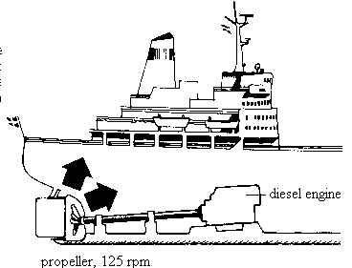

The advance of processing technology in piezoelectric materials has resulted in their successful applications in specialist applications in structures. In active control systems, a greater number of smart structures incorporating piezoelectric materials applications have been used for a variety of sophisticated mechanical tasks as feedback systems controlled by a computer such as in the active control of noise and vibration. Patch type Piezoelectric materials have been broadly used as sensors and actuators by using anti-oscillations to reduce radiated noise.

- Self healing and repairing :

Self healing structures react to damage producing some action to restore it to its undamaged condition followed by air curing of the released chemicals in the cracks, leading to restoring the mechanical properties of undamaged composite . Once the glass fibres break, the chemical agent is released into the cracks of the polymer matrix and the composite can be healed. Significant crack arrest and life extension resulted when the in-situ healing rate is faster than the crack growth rate carried out a feasibility study on self healing which maintained the material’s water tightness (sealing) and mechanical properties (healing) in structures.
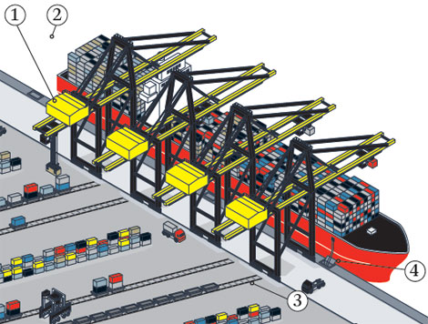

Shape memory alloys (SMAs) have been used as actuator in a self repairing joint. Layered SMA/PVDF films in flexible satellites were demonstrated in a self healing system with a SMA-driven bolted joint that senses change and tightens itself , which can reduce the maintenance cost of critical bolted joints.
Self healing can make the material safer, more reliable, longer lasting and require less maintenance cost especially in ship structures subjected to unexpected loading conditions such as hydraulic slamming or underwater explosions. It is also useful to make up the healing agent in quantities for small crack sizes initially. However, agents for self healing materials could be only a one shot solution rather than as a permanent measure to repair damage resulting from continual loads such as wave forces. In the case of SMA actuators for self repairing joints, a high amount of power is required as well as time for heating and cooling to achieve each material state (i.e. martensite and austenite).

- Shape Memory Alloy (SMA) Actuators :

SMAs would be suitable when a large displacement and slow response are required. SMAs have low bandwidth and are well suited mainly for slow actuation requirements. However, SMAs have poor fatigue properties. SMA elements may survive for a shorter time than steel components when subject to the same loading conditions such as twisting, bending and compression. Moreover, the slow response of SMA actuators are incompatible with high speed controllers. Representative types of actuators including piezoceramic (PZT), electroelastomer and shape memory alloys (SMAs)

Conclusion:
Each smart material has its own features with respect to different purposes, and even where smart materials have unique properties these may be suited to several different applications.
SMA could be used as vibration absorber ,shape controller or as self repairing. Piezoelectric materials can be sensors as well as actuators. Looking at future applications of smart material, there are limitations with implementing piezoelectric materials because their small range of mechanical movement may not suit large scale structures. In the case of ceramic based materials, their brittle nature makes them vulnerable to accidental breakage during handling and bonding procedures.
SMAs with their slow response, low efficiency, unpredictable movement and continuous heat source makes them suitable only for small-scale applications.

REFERENCE:-
www.google.com
www.wikipedia.com
BAZ, A, IMAM, K, & MCCOY, J. 1990. Active vibration control of flexible beams using shape memory actuators. J. of Sound and Vibration, 140(3), 437–456.

