ENVIRONMENTAL IMPACT OF TRANSPORTATION
THE GOVERNING THOUGHT
TRANSPORTATION DOES HAVE AT ANY STAGE AN ENVIRONMENTAL
IMPACT,
OCEAN TRANSPORT IS TODAY THE MOST EFFICIENT MODE OF
TRANSPORT
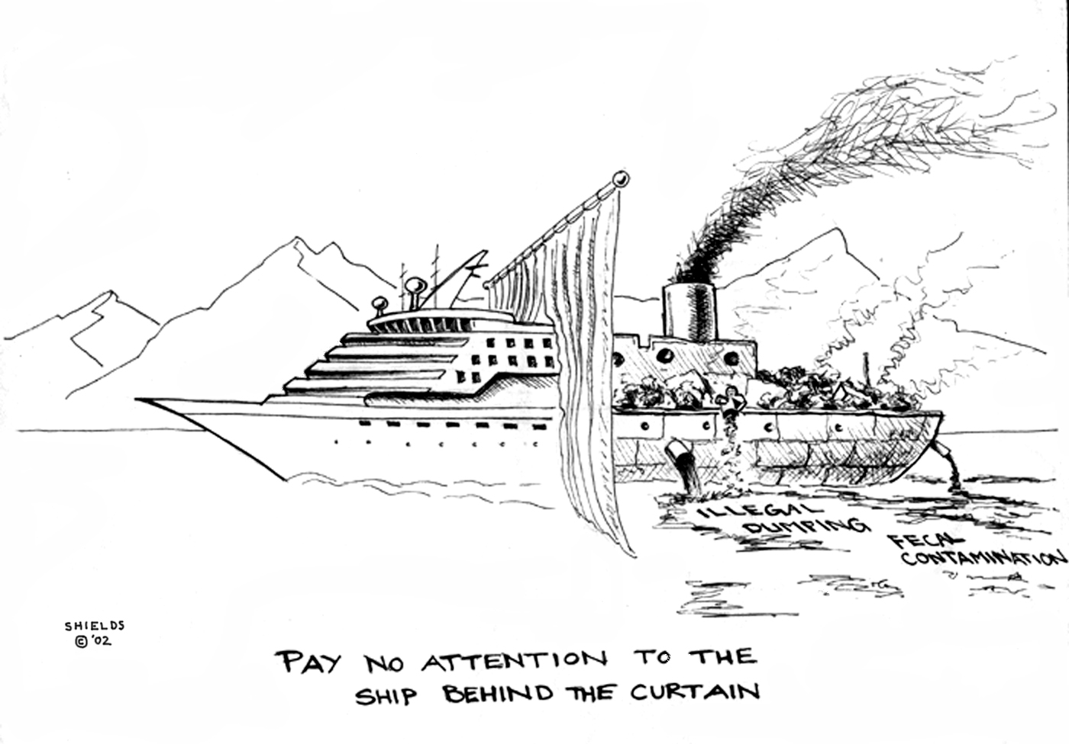
MARINE ENGG & RESEARCH INSTITUTE, IMU, MUMBAI.

PREPARED BY:

B.M.S FIRST YEAR (POLYVALENT)

1."CDT.SAURABH KUMAR SINGH

2."CDT GAURAV SAGAR

3."CDT.ANKUR SHARMA

CONTENTS

- ABSTRACT
- REGULATION AND INTERNATIONAL TREATIES
- MARINE POLLUTION
- SHIP POLLUTION
- SOURCES AND CAUSES
- EMISSION MODEL
- BALLAST WATER
- EXAUST EMISSION
- ACID RAIN
- OIL POLLUTION
- OIL SPILL
- RECENT DEVELOPMENT IN SHIPPING TO COP OFF MARINE POLLUTION
- LSF OIL
- OIL SLICK DETECTON SYSTEM
- BALLAST FREE SHIP
- ALTARNATIVE FUEL SYSTEM
- CONCLUSION
- BIBLIOGRAPHY

ABSTRACT
Ships had always enjoyed a reputation as one of the most environmental friendly means of transport. Although the ships are responsible for the carriage of 90% of world trade volume covering over 30000 billion tonnes a year. It has relatively much higher efficiency than other modes of transport such as only 10% of that is used by the road transport sector and 20% by the rail transport sector. It contributes to only 1.4% of world emissions and accounts for around 10% of emissions from all modes of transport put together.
Just as there is increasing pressure to reduce pollution from road vehicles and power stations or the shore side combustion plants, so the pressure is also growing on the shipping industry to reduce the harmful emissions from ship’s exhaust, from marine diesel engine and boilers. Pollution from the ships is mainly in the form of sox and NOx, Carbon oxides, unburned hydrocarbons, volatile organic compounds and particulate matter. These have been proven to have a (-) ve impact on health & environment. Acidification from sulphur dioxide can be usually detrimental to the plants, animals, humans & aquatic life forms and there is a long term consequences of carbon dioxide on global warming. Marine diesel engines just like any other internal combustion machinery emits all of those harmful products.
There is international effort focussed on the reductions of gaseous emissions that contribute to global warming and atmospheric pollution. Ships are responsible for a portion of this pollution contributing to environmental degradation increasingly these marine sources are being targeted for reduction.
The focus of many govt. and industry based marine transportation environmental initiative is the diesel engine as significant quantities of NOx are associated with diesel combustion engine.
Emission from shipping contributes significantly to the concentration and fallout of harmful air pollutants in the world .there are however technical means by which these pollutants could be cut by as much as 80-90%and are very cost effective as compared with what would have to be done to achieve the similar results by taking further measures on land based sources. Such reductions are needed for protecting health and environment and for shipping to develop into a more sustainable mode of transport

REGULATIONS AND INTERNATIONAL TREATIES

MARPOL has six annexure providing guidelines to prevent the pollution and maintain clean
sea. Essentially there are no specific international rules and regulations relating to
operational discharges arising from offshore exploration and production activities other than
those provided by the maritime organization in 1973/78 protocol, relating to the international
convention for the prevention of pollution from ships (MARPOL).
The IMO has a comprehensive regulatory regime administered mainly through the maritime and coastguard agency, or its equivalent abroad, and the classification societies to control pollution from ships.
Some 95% of the world’s trade is carried in ships and volume is increasing. This amounts to approximately 6500 million tones of cargo in 2000 and is predicted to double by 2012 with corresponding in ships.

A COMPARISON OF POLLUTION IN THE WORLD

1).MARINE POLLUTION
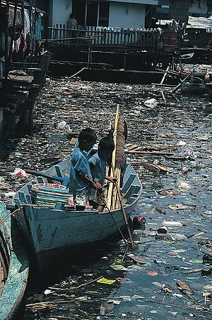

MARINE POLLUTION occur when harmful effects, or potentially harmful effects, can results from the entry into the ocean of chemicals, particles, industrials and residential waste, noise, or the spread of the invasive organism. Most sources are land based and often come from nonpoint sources such as agricultural runoff and wind blow debris. Not enough information is yet available about radioactive waste disposal and its pollution effect.
Many potentially toxic chemicals are taken by plankton and benthos animal, most of which are either deposite or filter feeders. In this way, the toxins are concentrated upward within ocean food chain. Toxic metal also introduced into marine food webs. They can cause change to tissue matter, biochemistry, reproduction and suppress growth in marine life. Also many animals feed have high fish meal. In this way marine toxins can be transfer to land animals and appear later in meat and dairy products.

- ship pollution
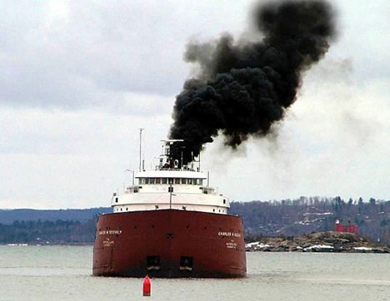

Ship pollution is the pollution of air and water by shipping. It is a problem that has been accelerating as trade has become increasingly globalised posing an increasing threat to the world’s ocean and waterways as globalisation continous. It is expected that, shipping traffic to and from the USA is projected to double by 2020.”. Because of increased traffic in ocean ports, pollution from ships also directly affects coastal areas. The pollution produced affects biodiversity, climate, food and human health. However the degree to which humans are polluting and how it affects the world is highly debated and has been a hot international topic for the past 30 yrs.

Sources and causes
Ships can pollute the waterways and the oceans in many ways. For instance, spills from oil tankers and chemical tankers, and ejection of sulphur dioxide, nitrogen dioxide gases into the atmosphere from exhaust fumes. Discharge of cargo residue from bulk carriers can pollute ports, waterways and oceans. Ships create noise pollution that disturbs natural wildlife, water from ballast tank can spread harmful algae and other invasive species. In many instance vessels due to a variety of reasons internationally discharge illegal waste despite for and domestic regulation prohibiting such actions.
The section describes how ship pollutes the ocean; for the protocol of 1978 relating to the international convention for the prevention of pollution from the ships of 1973, sometimes abbreviated as ship pollution.
There are many emissions which effect pollution, such emissions are given below:

IMPACT CHAIN OF SHIP EMISSIONS

ENGINE EMISSIONS (ME AND AUX

GEOGRAPHICAL DISTRIBUTION OF EMISSIONS
THERE ARE VARIOUS AGENTS WHO FORMULATE THE EMISSIONS OF THE SHIP BY
COLLLECTING VARIOUS
INFORMATIONS FROM THE SHIPPING COMPANIES BY VARIOUS MEANS. SOME OF
THEM ARE
COADS:
• BASED ON 6,931 SHIPS REPORTING OF ROUTINE METEOROLOGICAL
OBSERVATIONS, IDEALLY AT 6-HOURS INTERVALS .
• THE DATA FOR 1996 IS STATISTICALLY SUMMARISED ON A MONTHLY BASIS
WITH A 1°X1° SPATIAL RESOLUTION.
PURPLE FINDER:
• COMMUNICATE WITH EACH VESSEL'S INMARSAT-C TERMINAL AND
AUTOMATICALLY REPORTS POSITION.
• PF HAS SUPPORTED US WITH A FLEET MAP ON 1°X1° FOR YEAR 2000 THAT
CONTAINS VESSEL OBSERVATIONS FOR 1863 OCEAN GOING CARGO
VESSELS.
AMVER (AUTOMATED MUTUAL-ASSISTANCE VESSEL RESCUE SYSTEM) :
 12,550 SHIPS THAT REPRESENT VERY WELL THE INTERNATIONAL
MERCHANT FLEET.
 ADVANTAGE- SHIP TYPE AND SIZE CAN BE IDENTIFIED.
 THE SPATIAL RESOLUTION OF THE DATA IS 1°X1°.

- BALLAST WATER
Ballast is any solid or liquid that is brought on board a vessel to increase the draft, change the trim, regulates the stability or to maintain stress loads within acceptable limits. Today, water has become the ballast of choice, replacing rocks and sand that had been used prior to the 1980s.When a larger vessel, such as a container ship or an oil tanker unloads cargo, seawater is pumped into compartments in the hull. Similarly, when a larger vessel is being loaded it discharges seawater from these compartments. The sea water is meant to help stabilize and balance a ship. Ballast discharges from ships are responsible for tar balls in the open ocean sand seas, and can cause problems navigating tanker routes. Nevertheless, the discharge of ballast water only accounts for a small percentage of oil pollution in the marine environment.
A cargo ship pumps ballast water over the side

Ballast water taken up at sea and released in port is a measure source of unwanted exotic marine life. The invasive freshwater zebra mussels, native to black and Caspian sea were probably transported to the great lakes through it.It was first introduced in 1982, and thought to have been transported to the Black Sea in a ship’s ballast water. The population of the jellyfish shot up exponentially and, by 1988, it was wreaking havoc up on the local fishing industry. “The anchovy catch fell from 204,000 tons in1984 to 200 tons in1993; sprat from 24,600 tons in 1984 to 12,000 tons in 1993; horse mackerel from 4,000 tons in 1984 to zero in 1993.” Now that the jellyfish have exhausted the zooplankton, including fish larvae, their numbers have fallen dramatically, yet they continue to maintain a strangles hold on the ecosystem. Recently the jellyfish have been discovered in the Caspian Sea. Invasive species can take over once occupied area, facilitate the spread of new diseases, introduce new genetic material, alter landscapes and jeopardize the ability of native species to obtain food. “On land and in the sea, invasive species are responsible for about 137 billion dollars in lost revenue and management costs in the U.S. each year”. In addition to introducing non native species into new environments, ballast and bilge
Discharge from ships can spread human pathogens and other harmful diseases and toxins
potentially causing health issues for humans and marine life alike. Discharges into coastal
water along with other sources of marine pollution have the potential to be toxic to marine
plants, animals, and microorganisms causing alterations such as changes in growth, disruption of hormone cycles, birth defects, suppression of the immune system, and disorders resulting in cancer, tumors, and genetic abnormalities or even death. They may also have the opposite affects upon some marine life stimulating growth and providing a source of food. Sources of seafood can become contaminated and unhealthy for consumption.
Not surprisingly, cholera outbreaks have been attributed to ship operations. “Current research indicates that the bacterium responsible for causing cholera, Vibrio cholerae can spread through attachment to marine organisms in ship ballast water.” Shellfish and drinking water can then be contaminated when the ship discharges its ballast water.

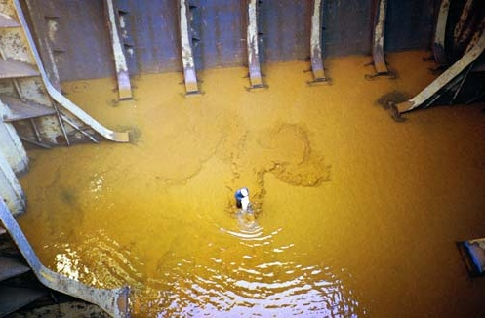
Sediments left after de-ballasting from ships’ ballast tank

- EXHAUST EMISSION

Exhaust emission from ships are considered to be a significant source of air pollution, with 18-30% of all nitrogen oxide and 9% of sulphur oxide pollution. “By 2010 up to 40% air pollution over land could come from ships.
Impact of SOx, NOx and other particle:

About sulphur oxide:

- Sulphur dioxide (SO2) is a colourless gas,
- Soluble in water and can be oxidised within airborne water droplets.
- Natural sources from volcanoes, oceans, biological decay and forest fires.
- Man-made sources of sulphur dioxide are fossil fuel combustion,
- Major health concerns effects on breathing, respiratory illness,
- Sulphur dioxide mixes with water vapour producing sulphuric acid.
- Acidic pollution transported by wind over many hundreds of miles, and
deposited as acid rain.
- Plants & animals disappear

About nitrogen oxide:

- Nitrogen oxides refer to two species of oxides of nitrogen: Nitric oxide (NO)
and Nitrogen dioxide (NO2).
- Plays a major role in the atmospheric reactions that produce ground-level
ozone or smog.
- Natural sources include bacterial and volcanic action, and lightning
- Man-made emissions are mainly due to fossil fuel combustion
- This acidic pollution can be transported by win over many hundreds of miles,
And deposited as acid rain.

Marine industry preferred residual fuel over distillate fuel when the distillate fuel prices went high up. As the refinery processes are getting better they are trying to extract more & more valuable products from the crude thereby detoriating the quality of residual fuel. As the development of marine fuel is inexorably tied with the regulations of exhaust emissions by ships.
The increase in shipping driven by 2-stroke main engines is helping create more and more exhaust emissions, having a deadly impact on the environment. The result is the establishment of SECAs and various regulations like MARPOL & EU. This reflects the increasing efforts to reduce emissions like SOx, NOx &particulate from ships. Shipping now looking for various technologies and solutions that keeps its pace with the ferocious rules, yet profitable to it.

OIL POLLUTION
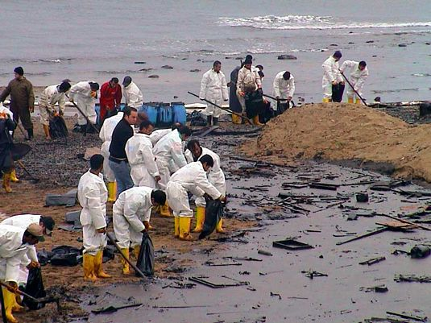

Oil pollution of the marine environment

Traditional shipping and oil transportation routes are more exposed to the impacts of oil-polluted discharges from tankers and other vessels than other areas. For example, observations in the Caribbean basin [Atwood et al., 1987; Jones, Bacon, 1990; Corbin, 1993], where annually up to 1 million tons of oil enter the marine environment, showed that about 50% of this amount came from tankers and other ships [Hinrichsen, 1990]. In the Bay of Bengal and the Arabian Sea, oil pollution inputs from tanker and other ship discharges equal, respectively, 400,000 tons and 5 million tons of oil a year [Hinrichsen, 1990]. The most intense tanker traffic exists in the Atlantic Ocean and its seas, which accounts for 38% of international maritime oil transportation. In the Indian and Pacific Oceans, this portion is, respectively, 34% and 28%

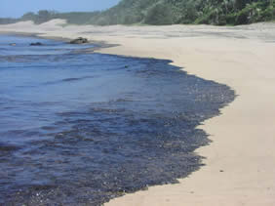

Although this tendency of decreasing oil pollution caused by tanker transportation and shipping gives some reason for environmental optimism, two alarming circumstances should not be neglected. One of them has already been mentioned. Strikingly high volumes of oil's input are reported for some regions (e.g., the Caribbean basin, northern part of the Indian Ocean, Mediterranean Sea). These volumes may total hundreds of thousands or even millions of tons of oil [Hinrichsen, 1990]. They are directly connected with highly intensive shipping and tanker transportation in these areas. Some estimates indicate that annual oil pollution input into the marine environment may reach 7.3 million tons [Panov et al., 1986; GESAMP, 1994]. Other researches give even higher figures. For example, data summarized by S.M. Konovalov [Konovalov, 1995] suggest that global oil input into the World Ocean reaches 20 million tons a year, and pollution caused by tankers accounts for 50% of it. Note that annually about 6,500 large tankers transport more than 1.2 billion tons of oil and oil products. In spite of the fact that the latter estimates are considerably higher than the ones based on official statistics (Table 2), they have not been refuted thus far. This raises serious concerns about the actual levels of oil pollution in different marine regions and in the World Ocean in general.

The other circumstance that can affect the tendency of decreasing oil pollution from tankers involves accidental spills. Accidental situations during oil tanker transportation repeatedly happened in the past. Remember, for example, two relatively recent tanker accidents, the Exxon Valdez and the Braer, which spilled 40,000 tons of oil into Alaskan waters in 1989 and 85,000 tons near the shore of the Shetland Islands in 1993, respectively. The probabilistic nature of accidental situations and highly variable volumes of spilled oil do not allow definite conclusions

OIL SPILL – NON OIL TANKER

On Nov. 07, 2007 an oil spill of 58,000 gallons occurred by MV Cosco Busan Container
ship, 810ft long, 65,131 tons, (Heavy duty bunker fuel oil), caused contamination throughout

THE ACTION TAKEN AFTER THE OIL SPILL
Miles of Californian coastlines were contaminated after 58,000 of gallons of oil spilled
from a container ship. The ship was damaged when it struck to a support tower of the
sanfransisco-oakland bay bridge
- 9,500 gallons had been contained
- 58,000 gallons leaked

CONSEQUENCES:
- 200 birds dead.
- Mammal’s fish and marine lives dead
- Beaches polluted
- Notwithstanding 18000ft long containment boom
- 5 skimmers, hundred of volunteers working
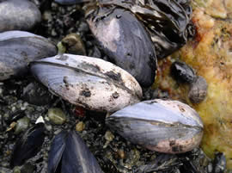

RESPONSE TO THE EXXON VALDEZ SPILL

During the days and weeks after the spill began,

- Coast Guard and Exxon responders and others trying to control the effects of the
huge oil slick used NOAA's predictions of the trajectory of the spilled oil and
NOAA scientists' observations of the oil, made during overflights and sampling
trips to affected shorelines.

- Responders used ESI maps of the region, which show the locations of especially
oil-sensitive animal and plant populations, to decide which areas were most
important to protect and to eventually clean up.

LONG-TERM MONITORING

Questions emerged during the response to the Exxon Valdez spill
- How quickly and completely would affected areas recover from the spill?
- Did spill cleanup measures--which included washing oiled beaches with hot
water and mechanical scrubbing of beach rocks--speed up or slow down
regrowth of the plants and animals that populated those areas?
Beginning in 1989, biologists began a long-term study to monitor the area affected by
the spill.
Their goal is to evaluate the effects both of the oiling and of subsequent cleanup
treatments. These researchers are observing how quickly, and in what ways, shoreline
habitats around the sound are recovering.

“By far the biggest potential means of reducing the energy consumed per tonne mile carried is through improvements in the amount of time a vessel spends in ballast.”
“Efficiency is also a factor of speed used so a relatively small reduction in speed can produce a relatively large reduction in emissions.”
“What’s needed, essentially, is more creative thinking about contracts and scheduling involving owners, traders and charterers.”

Fouling – the coating of slime and algae that collects on a ship’s hull and propellers so
reducing its sailing efficiency – is a second focus area for the industry

RECENT DEVELOPMENT IN SHIPING TO COP OFF MARINE POLLUTION:
- LSF (Low Sulphur Fuel) Oil:
The traditional fuels being used in shipping is HFO which has sulphur content greater than 1.5%, but it is causing more sulphur pollution. So, to reduce emissions, the sulphur content is lowered. Hence low Sulphur Fuel Oil is the residual fuel which basically has Sulphur content less than 1.5 % (m/m).
MERIT & DEMERIT OF LSFO
MERIT:
LSFO (0.5%) reduces sulphur emission by about 75% till 2010. The net benefit will be 6.6 to 10.4 million euro (about 7.5 times higher than the initial cost). The economical benefit obtained due to the consistent use of LSFO may lead to a total amount of
12 billion €/annum (*depending on market fluctuations).
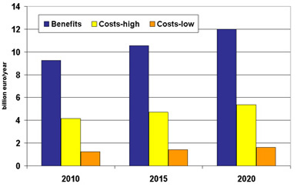

Using LSHFO (1-1.5%) we can bring down cylinder maintenance cost by 43.8%, this can be done easily and efficiently by just controlling the FEEDSTOCK of the lubrication oil which contributes around 73% of total cylinder maintenance cost in a low speed diesel engine

DEMERIT:
- Reduction in Etching/Accelerated wear due to LSFO:

Etching is the phenomenon which provides minute porosity or formation of Small pockets on the surface allows LUB. Oil film adhere better to the surface hence providing better running Surface, in the Liner surface which is attributed as an important factor for proper and LUBRICATION.
The extent of the etching is controlled by balancing Lubricant’s alkalinity, measured by Base Number or BN, and the sulphur content of Fuel Oil.

EXTENT OF ITCHING BALANCE B/W LUBRICANTS
For Proper LUBRICATION ALKALINITY & SULPHUR (%)
And SEALING OF LSFO

- OIL SLICK DETECTION SYSTEM:

Monitoring and detecting oil spills as they occur in real-time accelerates response time, thus
substantially reducing cleanup/remediation costs, and limiting damage to the environment. Building on 50 years of sensor/systems innovation, Inter Ocean has developed the optimum solution for this requirement. The Slick Sleuth Oil Spill Detection System is a highly effective, cost-saving system, which is easy to install and requires no maintenance. Because the oil detection sensor is mounted above the water, maintenance and downtime are virtually eliminated. There is no marine fouling, leaking, exposure to ships, lost moorings, or other liabilities often associated with buoys and in-water sensor packages.

- BALLAST FREE SHIP:

NOBOB (no-ballast-on-board) vessels are loaded with cargo, and thus their ballast tanks have been pumped out to the extent possible for given de-ballasting conditions. NOBOBs constitute the majority of saltwater vessel entries to the Great Lakes. Until August 2005 they entered without any management policy (such as ballast water exchange) aimed at reducing the risk of non-indigenous species introductions via ballast water discharge, since theoretically they do not carry and therefore would not be discharging foreign ballast water. However, many of these ships add Great Lakes water as ballast at ports within the Great Lakes ecosystem until they have a cargo to load. When new cargo is loaded, the discharge of ballast water added in the Great Lakes can include organisms that were in the un-pumpable residual ballast water and sediment in the ballast tanks when the ship entered the system, thus providing an unregulated avenue for new species introductions within the Great Lakes.

- ALTARNATIVE FUEL SYSTEM

In today’s scenario Sustainable Development is the need of our Shipping Industry. Though much of the research has been conducted by researchers all over the world to enhance and develop the Nonconventional fuelling means to propel the marine ships, still a lot of effort is required to put them to use in an economical way.

It’s well known that around 2030 there will be an acute shortage of fossil fuel, so to overcome the problem the RESEARCH and DEVELOPMENT organizations should a global effort to develop alternative sources. We should start introducing these alternatives initially in
Some vessels, then slowly installing it in most of the vessels, so that we are well conserved before the stocks are finished which were earlier the soul means of ship propulsion.

The two basic reasons for the development of non-conventional fuel alternatives for the Shipping industry are:

- The conventional fuels are not everlasting, with the current rate of consumption they will soon be depleted in near future.

- Environmental concern holds much more relevance in our Shipping Industry than any other industry, as it contributes about 98% of world trade hence it should be our prime endeavour to curb the increasing pollution done by this field.

Hence with the implementation of international regulatory body for marine pollution (MARPOL), the requirement of alternative fuels which are eco-friendly and are long lasting becomes a necessity. There are some of the Non-conventional alternatives, eco-friendly methods of

ship propulsion. They are listed below:

1. Bio Fuel.
2. Fuel Cell.
3. Nuclear fuel.
4. LNG/LPG as fuel.

CONCLUSION

•" The protection of the environment is something that can be, and must be, addressed at every level.

•" The MARPOL 73/78, IMO and others, at the global regulatory level, is only really effective if the measures we adopt are widely implemented, on a daily basis.

•" the following parameters will have the greatest effect towards achieving this goal in the maritime area:

1. " Maintaining the correct practices of strong environmental rules and regulations.

2. " Preventing air pollution by reducing emissions.

3." Increasing energy efficiency as stated earlier.

4." Reducing fouling, painting propellers, preventing oil spills.

BIBLIOGRAPHY:
- www.castrolmarine.com
- www.wartsilla.com
- www.google.com
- www.shipmarine.com
- www.oilspillresponce.com
- www.imo.org

REFERRED BOOKS & MAGAZINES
- POUNDERS MARINE DIESEL ENGINE

- REEDS MOTOR ENGINEERING

- SHIP MAG

