Sharklet: Application of Biomimicry for Drag Reductions in Marine Vessels
Snehadri Banik, Tolani Maritime Institute, Induri, banik.snehadritmi@gmail.com

Abstract:
Marine mammals such as Shark travel distances of thousand miles through out their life. Micro-organisms, algae, barnacles and other forms of "sea gunk" collect and build up on its skin. For Sharks, and the many other marine animals it is just a harmless part of nature. However, for the millions of ships travelling through sea and ocean waters, this process known as "bio-fouling" has more serious implications. The collation of "sea gunk" on ship hulls can increase a ship's drag by up to 15%. This reduces the ship's hydrodynamic efficiency, making it travel slower, consume more fuel and cause more pollution. Antifouling paints such as tributyltin, or TBT, which kill algae and barnacles have been banned worldwide by the International Maritime Organization. Thus, in order combat the environmental and financial costs of bio-fouling, biomimicry will turn out be a breakthrough technology. This paper deals with the application of biomimicry in marine vessels. Using a combination plastic-and-rubber coating by mimicking the shark's scaly skin patterns on plastic, a version of shark skin that is made up of billions of tiny raised, diamond-shaped patterns, visible under a microscope is developed called “sharklet”. Each "sharklet" diamond measures 15 microns and contains seven raised ribs that resemble different lengths of raised horizontal bars. Too tiny to be felt, and not even easily visible to the naked eye, the shark scale like pattern can prevent extremely small organisms from binding. Given that the annual global shipping trade transfers nearly 8 billion tonnes of cargo across continents, the environmental impact of this invention, with regards to the potential in emission reductions, is impressive.
Keywords: TBT, Riblet, Sharklet.

- Introduction
Desired higher ship speeds can be achieved through many performance enhancement techniques. One of the techniques is reducing drag on ships’ hulls by imbuing their surfaces with hydrophobic properties. Zhao and colleagues have observed hydrophobic characteristics of shark-skin models for riblets, which can be used to achieve drag reduction. The results indicated that the proposed shark skin model is able to reduce contact angles suitable as micro-riblets (Wang et al., 2014) The implementation of micro-riblets has been used widely in various applications, such as turbine blades, aircraft, and antifouling devices. Besides increasing speeds, drag reduction also reduces fuel consumption in the aviation and shipping industries (Chamorro et al., 2013; Stenzel et al., 2011; Abbas et al., 2013).

In nature, micro-riblets are avalaible on shark skin, and they make sharks able to move efficiently in the water. Many researchers have sought to replicate shark skin using various techniques. Liu and colleagues (Liu & Li, 2012) successfully replicated shark skin using PDMS(Polydimethylsiloxane). Zhao and colleagues (Zhao et al., 2012) introduced a vacuum casting replication of microriblets on shark skin for drag-reducing applications. The pitch distance for shark skin is 100 µm, and the riblets’ height is up to 50 µm, as shown in Figure 1 (Liu & Li, 2012; Zhao et al., 2012).
  - Biomimicry
Biomimetics or biomimicry is the imitation of the models, systems, and elements of nature for the purpose of solving complex human problems. The terms "biomimetics" and "biomimicry" derive from Ancient Greek: βίος (bios), life, and μίμησις (mīmēsis), imitation, from (mīmeisthai), to imitate, from μῖμος (mimos), actor. A closely related field is bionics. Living organisms have evolved well-adapted structures and materials over geological time through natural selection. Biomimetics has given rise to new technologies inspired by biological solutions at macro and nanoscales. Humans have looked at nature for answers to problems throughout our existence. Nature has solved engineering problems such as self-healing abilities, environmental exposure tolerance and resistance, hydrophobicity, self-assembly, and harnessing solar energy. Research is still being carried out by scientist all over the world in the domain of Biomimcry.
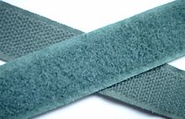
Fig. 1: The tiny hooks on bur fruits inspired the Velcro tape.

  - Biofouling
Biofouling or biological fouling is the accumulation of microorganisms, plants, algae, or animals on wetted surfaces. Such accumulation is referred to as epibiosis when the host surface is another organism and the relationship is not parasitic.
Marine organisms, such as algae spores and barnacles, settle and adhere to the hulls of ships causing a reduction in ship efficiency. This type of biofouling incurs large functional and monetary costs to both military and commercial vessels such as reduced ship speed due to drag, increased fuel consumption, cost of dry-docking for cleaning, and loss of hull strength from corrosion. Paints containing tributyltin (TBT) and copper have been successful at combating this problem. However, due to their toxicity, the use of these paints are not environmentally friendly and restrictions have been put on their use worldwide by 2008. A non-toxic substitute is therefore desired that reduces settlement and enhances release of marine biofouling organisms.
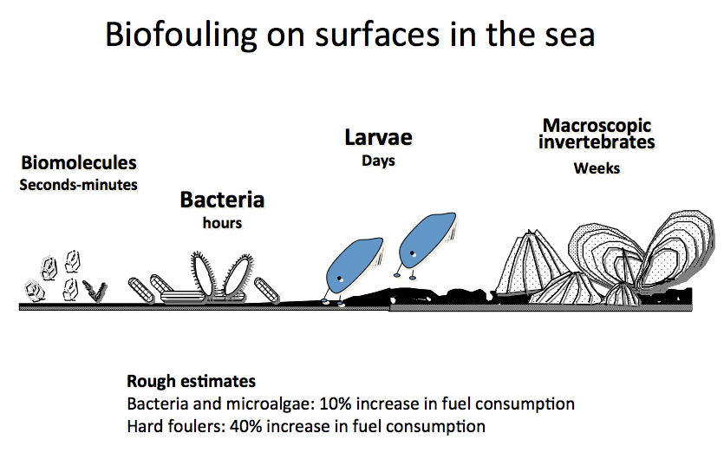
Fig. 2: Biofouling

    - Effects of Biofouling
The fouling of ships results in a reduction of speed, an increased cost in fuel, and losses in time and money in applying the necessary -remedial measures. The immediate effect is due to an increase in the resistance to movement of the hull through the water's phenomenon known as frictional resistance. Since frictional resistance is the basic phenomenon on which the most important aspects of the fouling problem depend, and since it is a matter of some intricacy, the technicalities of the subject are treated in the following chapter, which summarizes some of the more comprehensive experimental data available. For present purposes, it will serve to point out that the accumulation of fouling may readily reduce the speed of the ship by several knots; and in the case of war vessels and other types of ships in which extreme speed is essential, its occurrence may result in the loss of advantages for which great sacrifice has been made.
In addition to the direct expense of the increased fuel consumption required to drive a fouled ship at a given speed and the increased wear and tear on machinery which this may entail, the expense of docking the vessel periodically for cleaning the bottom is great. The cost of placing a vessel in dry dock or on a marine railway, cleaning, and painting the bottom varies from $1,000 to $15,000, depending on the size of the vessel.
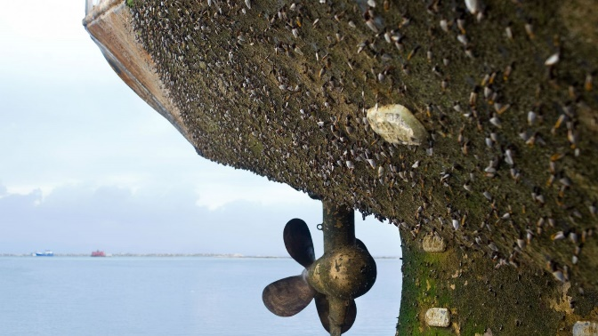
Fig. 3: Effect of biofouling on hull
  - Antifouling

    - Tributylin
Tributyltin (TBT) is an umbrella term for a class of organotin compounds which contain the (C₄H₉)₃Sn group, with a prominent example being tributyltin oxide.
The antifouling properties of TBT compounds were discovered in the 1950s in the Netherlands by van der Kerk and coworkers. The function of the biocide in the anti-fouling paint is to prevent the settling of organisms on the hull and to poison the organisms that do. Although an effective biocide, tributyltin was wrongly deemed safe environmentally. By the mid 1960s it became the most popular anti-fouling paint worldwide. TBT was mixed into paints to extend the life of antifouling coatings, and ships were able to continue operations for a longer time frame. The paints ensured fuel efficiency and delayed costly ship repairs. It is also an ingredient in some disinfectants, for example in combination with quaternary ammonium compounds.
The effects of antifouling paint go beyond the organisms that it is intended to kill. By poisoning barnacles, algae, and other organisms at the bottom of the food chain, TBT is biomagnified up the marine predators' food web. It has been shown to harmfully affect many layers of the ecosystem, including invertebrates and vertebrates, even humans. Toxic effects in some species occur at 1 nano-gram per litre of water.
TBT has caused deformations in oysters and sex changes in snails, according to Susan Sang, a wildlife toxicologist for the World Wildlife Fund in Canada. The chemical also accumulates in fish, sea birds and marine mammals, damaging reproductive and immune systems, Sang said.

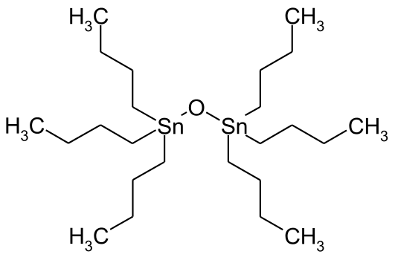
Fig. 4: Chemical structure of TBT

- Discussion
The Sharklet micropattern is comprised of millions of microscopic features arranged in a repeating diamond pattern. The dimensions of each feature are only microns wide and deep. Sharklet is engineered to produce an antifouling effect through enhancing the surface energy of commonly used materials.
The Sharklet micropattern is engineered to reduce the adherence and transfer of microbes. Sharklet represents a departure from traditional antimicrobial technologies. It does not use any chemical or metal additives to kill microorganisms, but instead provides a non-toxic, manufactured solution.
  - History
The idea of Sharklet was brought forward by Dr. Anthony B. Brennan, a professor at the University of Florida.
Brennan was looking at algae growth on some test panels at Pearl Harbour, accompanied by botanists and marine biologists from the University of Hawaii (UH). Brennan’s observation that a passing submarine looked like a whale sparked a conversation about which marine animals resisted fouling on their skin. After considering and rejecting whales, porpoises, manatees and sea turtles, the group agreed that nurse sharks remained algae-free, despite those sharks spending much of their time immobile.
2.1 Drag Mechanism
rag is commonly categorized into pressure and skin friction drag, where the shark skin riblet microstructures generally reduce the skin friction drag. Describing pressure drag is best accomplished by imagining walking through a pool of water, where the resistance is primarily due to the pressure or form drag. The pressure drag is the drag that occurs due to the required energy necessary to move the ﬂuid from the front to the back of the object, such as water moving around the one’s legs. This drag may be reduced with streamlined shapes, such as air foil designs common to aircrafts. Conversely, skin friction or viscous drag is the drag that occurs due to the interaction of the closest ﬂuid layer to the object’s surface, such as the skin of the one’s legs in the water. This drag is due to the attraction of ﬂuid molecules to the surface, which creates friction and thus resistance. Away from the surface the velocity of the molecules increases until the fluid achieves the mean ﬂuid ﬂow velocity. Higher viscosity ﬂuids exhibit higher drag due to the higher attraction between ﬂuid layers, which then leads to increased skin friction.
  - Shark Skin
Sharks have placoid scales, which consist of a rectangular base embedded in the skin with tiny spines or bristles that poke up from the surface.
Shark skin is designed with micro structured features that effectively control naturally occurring turbulent vortices, which leads to less momentum transfer and shear stress, and thus reduces drag. Therefore, much attention has been given to actual shark skin and the mechanisms at work. The skin of fast swimming sharks (such as Mako, Isurus oxyrinchus ) is covered with scales called dermal denticles, which contain specially sized and spaced riblets oriented parallel to the swimming direction. Riblets can also vary between different locations on the same shark. However riblets operate on similar principles, where low drag is achieved by efﬁciently directing water at the solid-liquid interface. The microstructured riblets encourage anisotropic ﬂow as well as control vortices on the skin naturally present in turbulent ﬂ ow. The riblets lift and presumably pin any vortices generated in the viscous sublayer, which leads to lower drag.
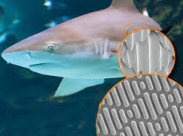
Fig. 5: Sharklet analogous to shark skin
One of the widely successful surface patterns for antifouling are inspired by shark skin is a combination of self-cleaning and low adhesion/drag surfaces. In general, the shape of the groves contributes to the low-drag and the self-cleaning properties of the shark skin. Analysis of the micro topographies present various marine species have suggested several key surface parameters that influence antifouling: low fractal dimension, high skewness of roughness and waviness, higher values of anisotropy, lower values mean roughness leading to improved antifouling characteristics. Carman et al. fabricated engineered multifeature topography in a polydimethylsiloxane elastomer to replicate the skin of fast moving sharks (Sharklet). Nearly 85 % reduction in the settlement of Ulva linza zoospores were achieved with the complex Sharklet topographies which consist of 2 μm wide engineered channels.
The primary Sharklet micro pattern is very small – about 3 microns tall and 2 microns wide. You cannot see the micro pattern with the naked eye and you can’t feel it with your finger, but it’s there, protecting the surface against bacteria and other microorganisms.
There are many variations of the Sharklet pattern that we make. Positive patterns protrude from the surface, and inverse pattern are recessed into the surface of the material. We can also modify the dimensions of the pattern depending on the application. Wider patterns have increased optical clarity due to less diffraction of light. These wider patterns are useful for applications where Sharklet will be covering something that needs to be observed, like a phone screen or a computer monitor in a hospital.
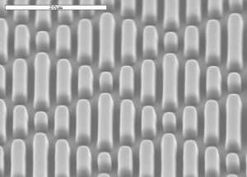
Fig. 6: Microscopic view
Manufacturing Process
The manufacturing process of the sharklet fibre is a complicated process. Although several processes have been invented. The most efficient one is that by Dan-Yang Zhao. A vacuum casting method is used to replicate the shark skin surface accurately. The fresh skin was pre-treated as a replication sample, and the replication mould of shark skin was manufactured by casting the unsaturated polyester resin under vacuum and laying of multi-layer glass fibres. Under vacuum condition silicon rubber was poured into the resin mould to obtain the replication film of the shark skin with micro riblets. The contour of the micro riblet was measured by a Talysurf CLI2000 machine to evaluate the replication accuracy. Based on the contacting angle measurement, the hydrophobic property of the micro riblets surface was investigated.
Results:
On carrying out the vacuum casting process and replicating shark’s skin on the hull. It was found that it was an effective replication technology which was suitable to form large area and highly accurate micro riblets on the surface of the shark skin. Based on the experimental results, the replicated film of shark skin played a significant role in reducing drag. The maximum and minimum of drag reduction rate were 18.6% and 9.7% respectively.
Conclusion:
This paper brings forward a new technology which in the future years can contribute towards greener and sustainable shipping. Not only that, this technology can also save thousands of dollars. The fouling of ships results in a reduction of speed, an increased cost in fuel, and losses in time and money in applying the necessary -remedial measures.
Biofouling of ships results in a reduction of speed, an increased cost in fuel, and losses in time and money in applying the necessary -remedial measures. Thus, in order combat the environmental and financial costs of bio-fouling, biomimicry will turn out be a breakthrough technology. This paper deals with the application of biomimicry in marine vessels. Using a combination plastic-and-rubber coating by mimicking the shark's scaly skin patterns on plastic, a version of shark skin that is made up of billions of tiny raised, diamond-shaped patterns, visible under a microscope is developed called “sharklet”. Each "sharklet" diamond measures 15 microns and contains seven raised ribs that resemble different lengths of raised horizontal bars. On carrying out the vacuum casting process and replicating shark’s skin on the hull the maximum and minimum of drag reduction rate were 18.6% and 9.7% respectively.
Acknowledgment:
I would like to thank Tolani Maritime Institute, Induri for providing me with an opportunity to do a research project on “Sharklet: Application of Biomimicry for Drag Reductions in Marine Vessels”.
I wish to express my sincere gratitude to Prof. Arun O. Mahajan, Prof.. Naresh Kumar Mishra and Prof. Nilima C. Joshi for their constant guidance and encouragement in carrying out this research project.

References:
- Chen, H., Zhang, X., Ma, L., Che, D., Zhang, D., Sudarshan, T.S., 2014. Investigation on Large-area Fabrication of Vivid Shark Skin with Superior Surface Functions. Applied Surface Science.
- Zhao, D.Y., Huang, Z. P., Wang, M. J., Wang, T., Jin, Y., 2012. Vacuum Casting Replication of Micro-riblets on Shark Skin for Drag-reducing Applications. Journal of Materials Processing Technology.
- https://biomaterialsres.biomedcentral.com/articles/10.1186/s40824-016-0064-4

